The United Kingdom Homework grid
Create a tourist leaflet on a city of your choice.  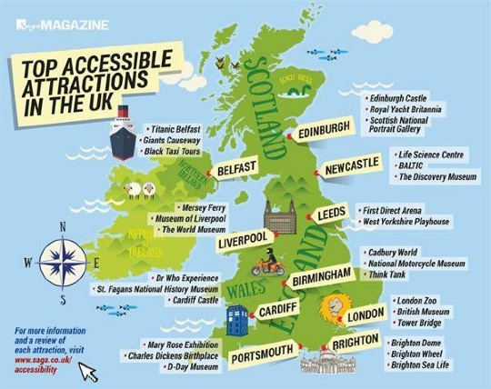 | Design your own island. Things you will need to include;  - A river  - An area of hills or mountains  - Small villages  - A large town  - A beach  - Any other locations you like | Write an acrostic poem using the letters from one of these words;  - England  - Ireland  - Scotland  - Wales | Create a fact page about the UK  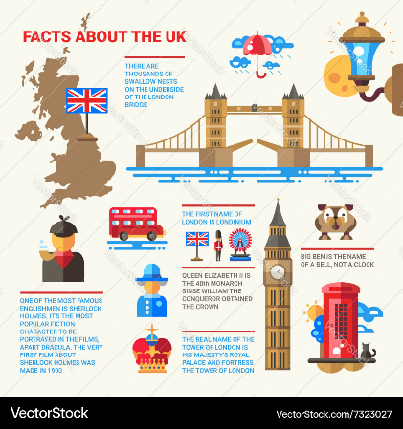
Make a 3D model or draw a UK attraction  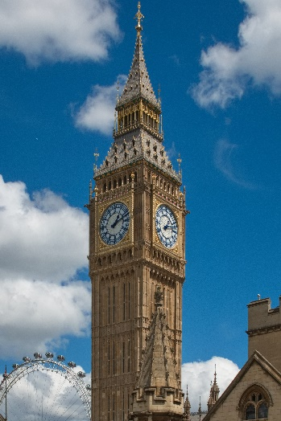 | Write a short adventure story.   | Make up little song/rhyme with a friend about the UK.   | Find out about a famous British artist. There are many, some examples to help;  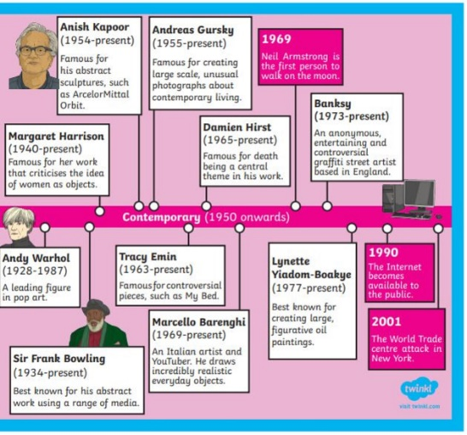
Create a fact file or poster about a famous person from the UK  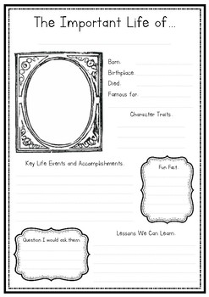 | Compare the UK with another European country  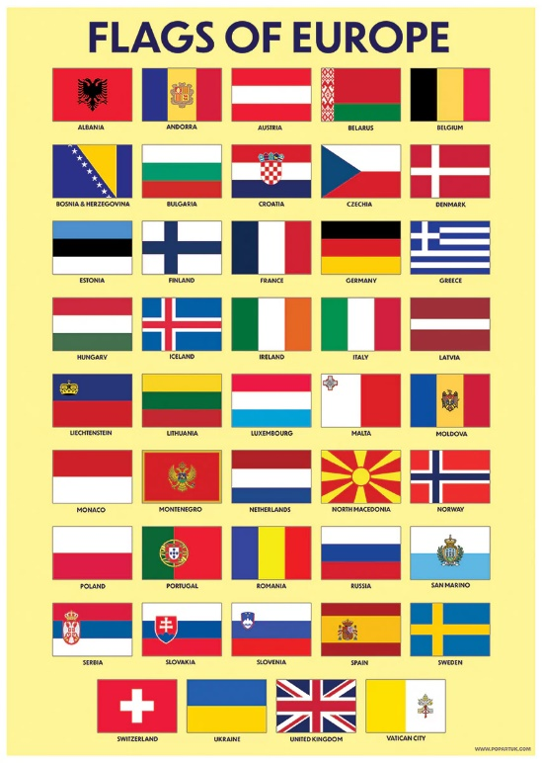 | Re-design the United Kingdom Flag  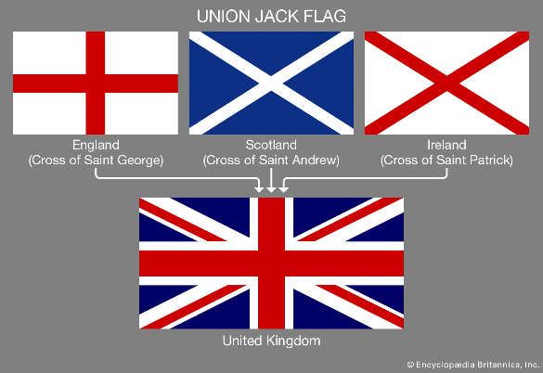 | Find out about your county symbol and draw and label it. Why was it chosen? What does each part represent?  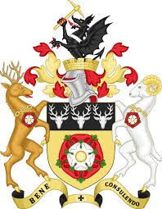
Choose a homework tasks to complete for Autumn term 1

