SPAG  - Punctuation revision  - Nouns – Common & proper  - Nouns – collective  - Verbs - action  - Verb phrases  - Verbs and sentence construction  - Subject and verb agreement  - Co-ordinating conjunctions  - Co-ordinating conjunctions joining parts of sentences  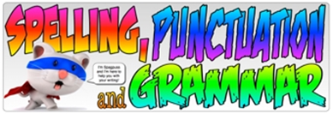  Weekly spellings on Fridays  (Don’t forget to log in to EdShed for practise) | English  The first half term of English will be taken up consolidating the building blocks of excellent writing with strong focus on grammar.  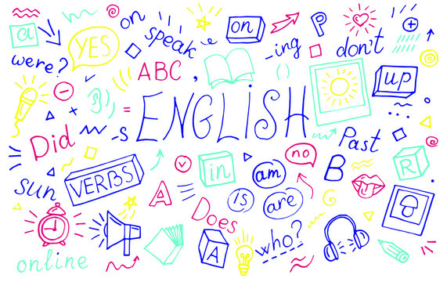 | Geography – United Kingdom  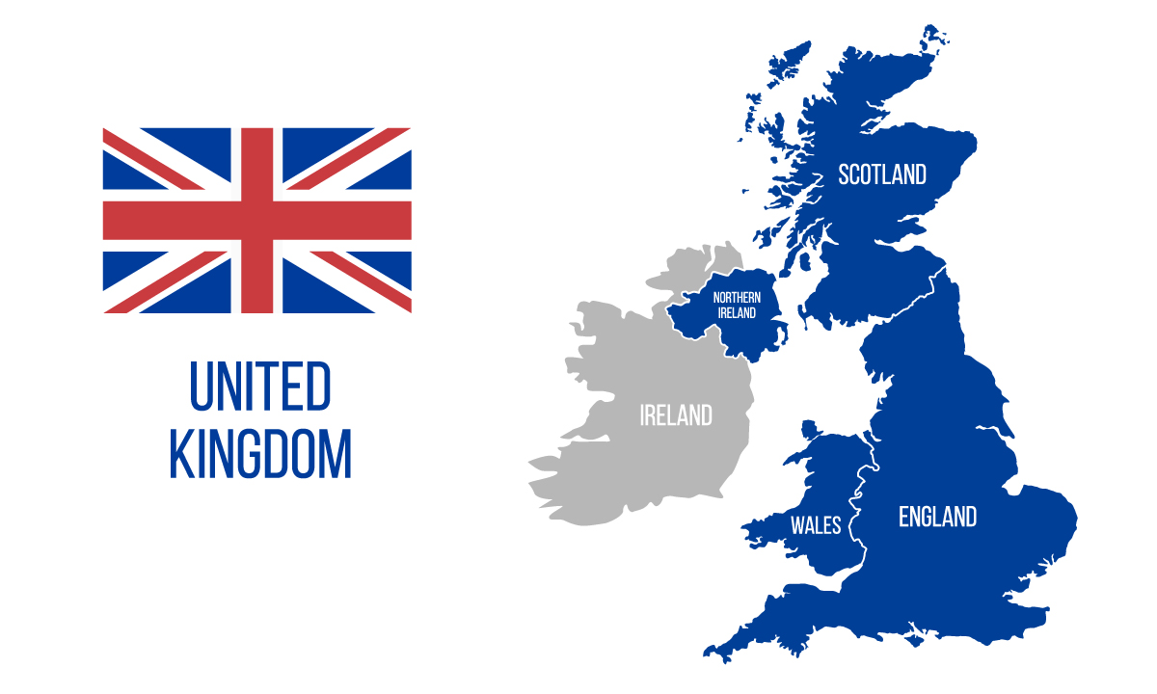  Children will take a look at the geography of the UK - from the physical features of mountains, rivers and seas to the man-made administrative regions and counties. They will find out how the UK has changed over time, looking at how London grew and how the population of the UK as a whole has changed throughout the course of history.
Maths  We will be focusing on the essential building block in maths of the place value of numbers, including;  - Representing numbers to 100  - Partitioning numbers to 100  - Number line to 100  - Hundreds  - Representing numbers to 1,000  - Partition numbers to 1,000  - Flexible partitioning of numbers to 1,000  - Hundreds, tens and ones  - Find 1, 10 or 100 more or less  - Number line to 1,000  - Estimate on a number line to 1,000  - Compare numbers to 1,000  - Order numbers to 1,000  - Count in 50s  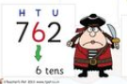  Times tables – Revision of 2x, 5x and 10x tables  Weekly tests on Fridays  (Don’t forget to log in to TTRockstars and Sumdog) | Science: Animals including humans?  In science we will be recapping and building on your child’s knowledge about how animals survive and stay healthy, and help them learn more about what makes a healthy, balanced diet. Children will learn about the nutrients that different foods provide and how these nutrients help our bodies. They will also explore how different animals eat different types of foods and need different proportions of nutrients. They will also look at food labels on packaging, show and gather information from food labels to help them answer questions.  Your child will also explore the different types of skeletons that animals have and compare these. They will learn some names of bones in the human body and carry out an investigation to explore if people with longer femurs jump further.  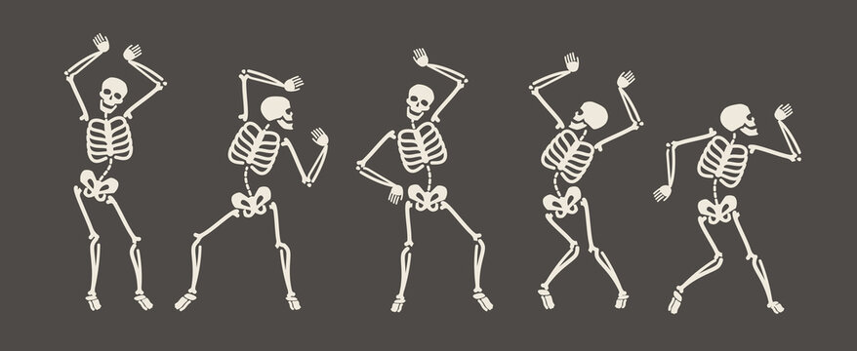 | PSHE - Keeping Safe  We will be exploring basic strategies to help keep themselves safe online e.g. passwords, using trusted sites, identifying misinformation, sharing information, who to trust, how to report. We will Identify situations where age restrictions apply and assess risk online/offline. (Including in the home and when playing out). Children will discuss ways to reduce risks at home and in the local environment in order to stay safe.  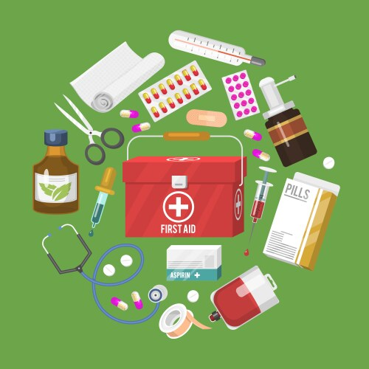  The children will also learn some basic first aid.
French

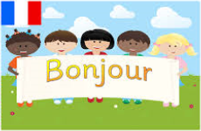
Your child will know learn French greetings and use them in conversations. They will also identify and use adjectives for colour, size and shape.
PE  This term in PE we will improving our skills and techniques in athletics.  Music  Your child will have the opportunity to learn to play stringed musical instrument every week. This will be delivered by the Derbyshire Wider Opportunities Team.  They will also use Charanga to learn to know five songs from memory and who sang them or wrote them.  ● To know the style of the five songs.  ● To choose one song and be able to talk about:  - Its lyrics: what the song is about  - Any musical dimensions featured in the song, and where they are used (texture, dynamics, tempo, rhythm and pitch) ○ Identify the main sections of the song (introduction, verse, chorus etc.) | Art/DT  Drawing and the growing artist will be our focus in art this term.  Children will develop an understanding of shading and drawing techniques to create botanical inspired drawings.  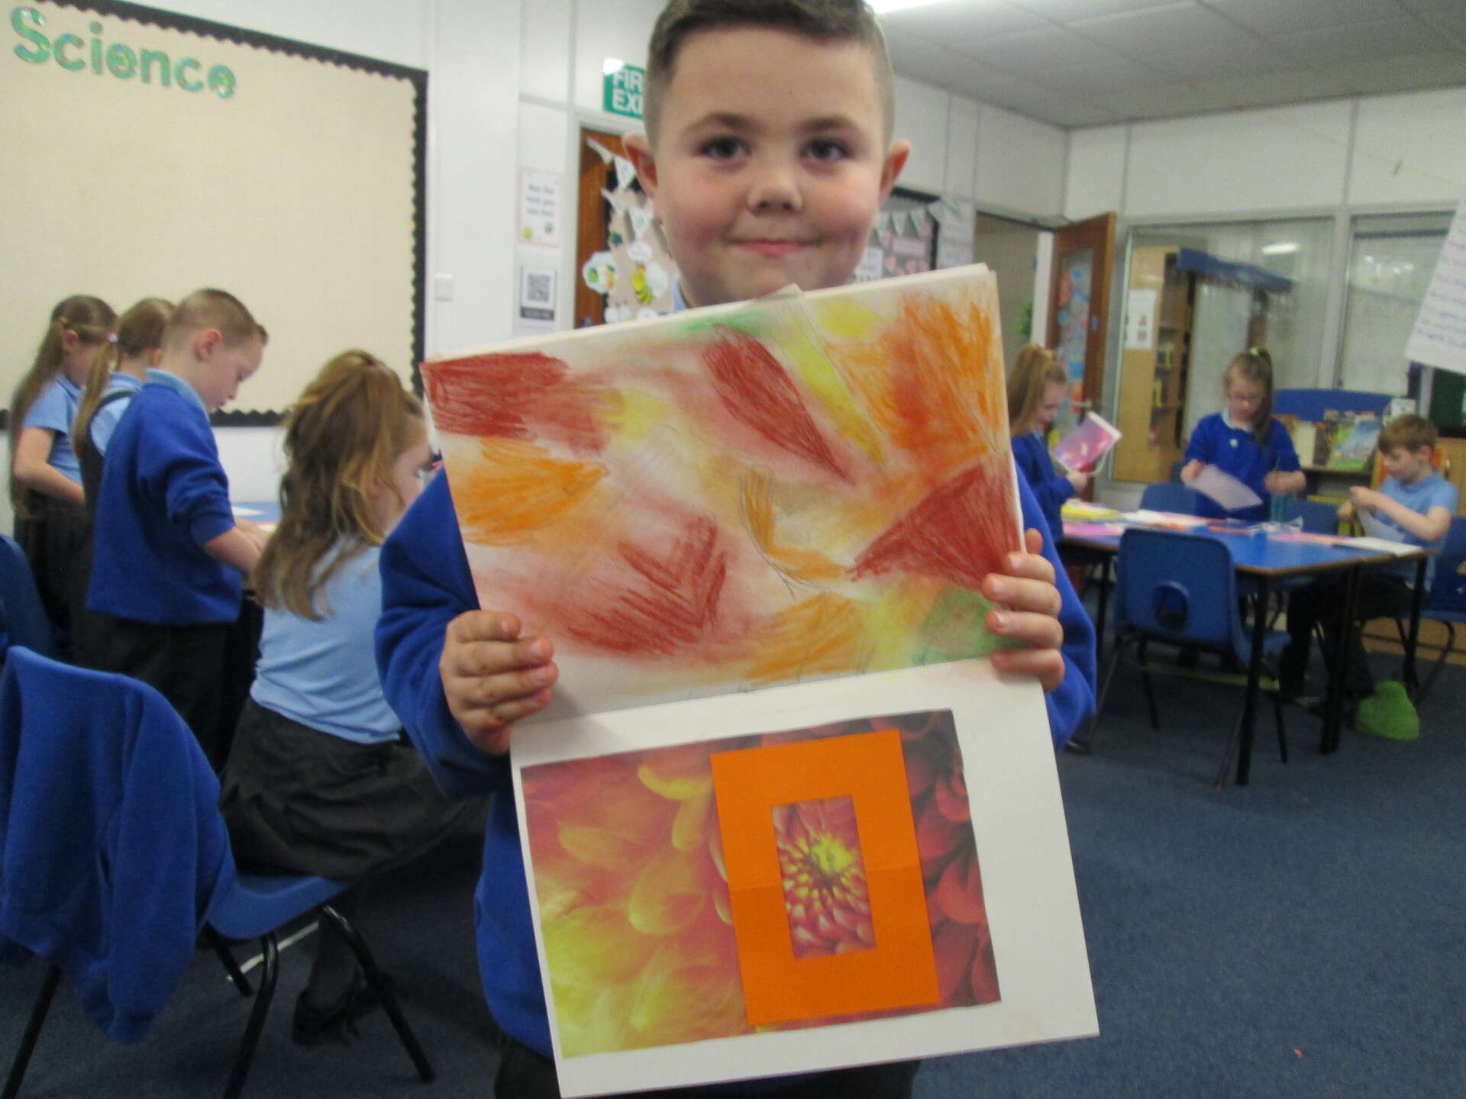 | RE  What makes us human?  Interpreting and using art to express beliefs about spirituality, inner self and the soul, the children design the cover and blurb for a book titled ‘What makes us human?’.  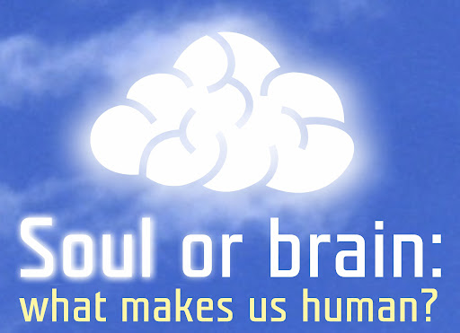  Computing  Learning how to send and edit emails, add attachments and how to be a responsible digital citizen by thinking about the contents of what is sent.  

