 **Class 3 Newsletter - Autumn**

Welcome back! I hope you’ve all had a good summer break. I am so excited to be working with Class 3 this year, we have lots of fun and interesting things planned, including themed days and trips later in the year.

A bit of a change to class 3 as we are now named ‘Class 3 Kingfishers’ and in our first week back we will collect lots of facts about kingfishers. Here are a few of them;

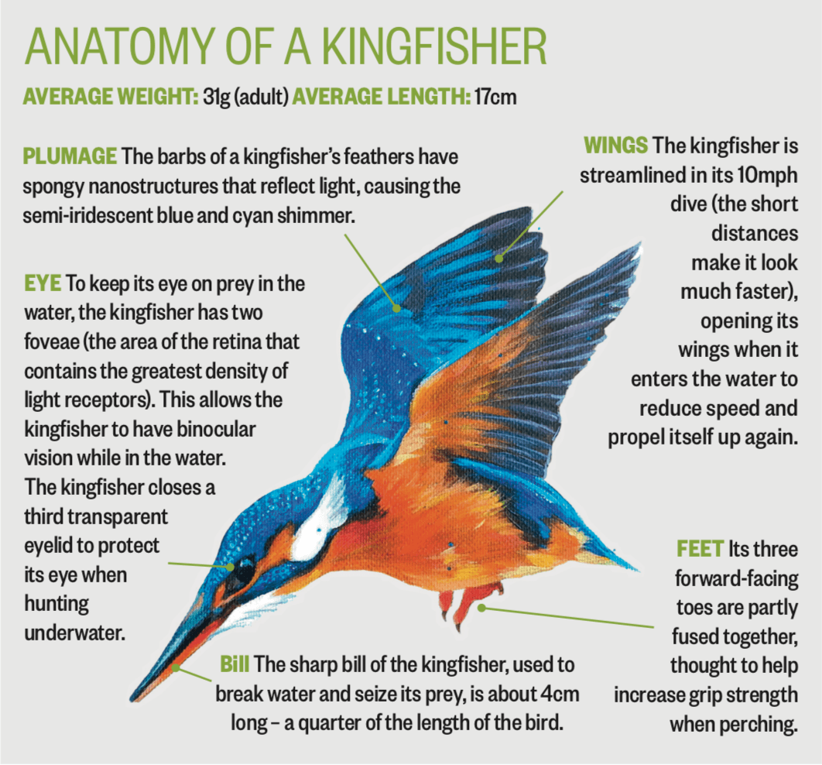

**Our topic this Autumn is;**

**Why are the Romans considered to be revolutionary?**

This term we will learn about the impact the Roman empire had on life in Britain. Childlren will learn about the spread of the Roman empire, the invasion of Britain and the eventual conquest. The children will also look in detail at some aspects of the Romanisation of Britain, such as the building of Roman roads and bathhouses. In addition to this, they will have the opportunity to learn about the British resistance of Boudicca and will act in role to look at the events of Boudicca's rebellion from different perspectives. We will investigate Hadrian's Wall, examining how, where and why it was built. The class will learn about the different features of the wall and use maps to determine its location. A lesson on Gods and Roman religion will help the children to understand more about the culture and beliefs of Roman people, and they will play and design games to consolidate their knowledge about the different Roman gods and goddesses.

Please check out on the school website for more detail of the other subjects we will be studying during the autumn term, including knowledge organisers.

**Logins and passwords**

I have given your child a folder which SHOULD BE KEPT IN A SAFE PLACE **AT HOME** PLEASE. It will contain their spellings for the year. In future, termly spellings will also be posted on the website for you to refer to if you wish. You should also have received;

* Logins and passwords for TT Rockstars, Charanga, Sumdog and Spelling Shed, learning platforms.
* Lists of Statutory Spellings (words children should know how to spell independently by the end of this year).
* Spelling, grammar and punctuation terms. (Word classes and definitions that children should learn for spelling, grammar and punctuation).
* Knowledge organisers giving information and vocabulary on some of the topics we will be studying this term.

**Please add these to the folder you have been given for future reference and safe keeping. PLEASE KEEP THE FOLDER AT HOME.**

**Keeping you informed**

At the beginning of each term I will post on the School website termly information, including spellings, knowledge organisers and key events. These will include everything that you and your child will need to know ready for the upcoming term. This is to save on paper, so please do keep checking the website for recent school newsletters and information too.

**PE in Class 3**

Children will have PE twice a week. One session will be taught by Amber Valley on Tuesdays and the other will be taught by me on Fridays. Children should come to school dressed in their PE kit on the days that they have PE. This consists of plain blue or black shorts, a plain white or blue T-shirt, plain black or blue jogging bottoms or leggings, a plain blue or black sweatshirt or hoodie and trainers with grip. Children should not be wearing branded tracksuits or football gear, sparkly t-shirts or fashion wear. Canvas shoes or sandals are not safe when taking part in physical activity. No earrings should be worn to school on these days please and long hair should be tied up.

Class 3 Kingfishers will go swimming in the summer terms.

**Reading expectation in school and at home**

In school your child will be part of daily guided reading groups and will also read individually to an adult at school. They will be expected to read ideally 5 times each week at home too. It does not always have to be their reading book, it may be a book of their own choice, a comic or even a newspaper. It would be helpful if reading at home was recorded in their reading record and signed by an adult each time, we need this in order to change children’s books appropriately. **Please fill in one box in the reading record book for each day your child reads.**

Your child has been given a reading record and a reading packet that they can use to keep their reading record and reading books in. They will need to bring this into school daily and place in their tray.

**Homework in Class 3**

There is an expectation that your child regularly logs onto TT Rockstars, Sumdog and Spelling Shed at home to complete tasks I have set for them**.** I will be monitoring how often your child logs onto these online platforms.

Please encourage your child to learn their times tables off by heart at home to support learning in school. We will be learning times tables daily and reciting them as well as completing weekly times tables tests on Fridays.

Alongside weekly homework, I would like your child to complete 2 pieces of homework each term relating to the topic that we are learning in class. Our topic for Autumn is Romans. I have attached a homework grid for your child to choose 2 tasks from. Children’s homework may take any form. It could be a PowerPoint presentation, a piece of writing, a combination of typed up research and hand-drawn pictures, a comic strip or they might like to do some artwork or produce a model, write a story, song, or poem. Children can complete their piece of topic homework at any point during Autumn term and they are more than welcome to bring it into school to show the rest of the class and, if possible, have it added to our topic display. However, if you would prefer to email your child’s topic homework to school then that is absolutely fine too! I can then print a picture of it out for display.

**Musical instruments**

This year your child will have the fantastic opportunity to learn to play a musical instrument. This year it will be violins or cellos. Music lessons will be delivered by the Wider Opportunities Team (More details to follow).

**Other useful information**

* If possible, could all uniform and water bottles please be clearly labelled**!** Children will keep their jumpers on their pegs if they take them off and their water bottles will stay on their desks throughout the day. However, making sure everything is labelled ensures good hygiene is followed and ensures there are no mix ups at home time!
* No toys are allowed in school, including trading cards.
* Mrs. Hicking will teach the children on a Tuesday afternoons.
* Every Friday your child will have a weekly spelling test of usually ten words. From Friday 3rd October, we will incorporate an additional 3 of the Statutory spellings each week.
* Your child will have a times table test each Friday.
* Your child has all the stationery they require in school. Please do not send in pencil cases or stationery.

**SNACKS**

A snack at break time is nice to have. Your child should bring in healthy snacks into school, **PLEASE….NO NUTS.** Some examples for snacks;

* Whole or sliced fruit.
* Vegetable sticks, e.g. celery, carrot, pepper, cucumber. ...
* Bag of plain popcorn.
* Bread sticks.
* Rice or corn cakes

If you have any questions or concerns, please do not hesitate to contact me – preferably at the end of the school day – when I will have a little more time and be more than happy to discuss anything.

Mrs Williams