ECaT
ECaT is a great opportunity to promote discussions, language, listening and communication skills and it really allows children to feel part of a team where we celebrate each other’s achievements and work! Every half term I send out a ‘Bucket list’ of activities that are linked to what we are learning about that half term. We recommend that you complete 2 of these activities each half term to gain the full benefit of ECaT. This should be alongside daily reading once your child receives their reading pack. Children can bring in their ECaT work or you can send us photographs of what they have been up to on our Class Dojo. I also love to see what you have been up to at home, any little achievements, holidays etc and the children love sharing these with their friends so please share these with us! The children really take pride in standing up and sharing things, it is always so lovely to see!
All ideas are linked to our learning this half term and our topic: Antarctica (Please see newsletter for more information). These are just some ideas but you guys have fantastic ideas so please feel free to be as creative with this as you wish. There is no pressure to be all singing and dancing though!
Many thanks Miss Goold
Crafty Ideas:  Make your own Antarctica animal/igloo/scene.  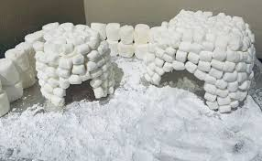  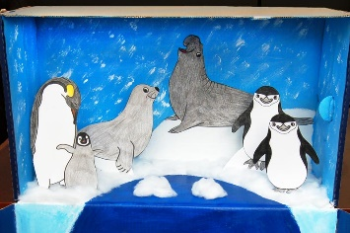  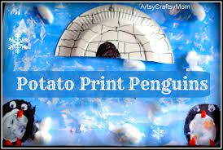 | Writing ideas:  - Have a go at writing your name, this could be on a rocket, in different colours.  - Write CVC words for things in your house.  - Have a go at spelling your tricky words.  - Write a short caption for a photo below. | Maths ideas:  - Use the rhymes below to help you form your numbers to 10.  -Fill up some containers with water and use the words ‘full’ ‘empty’ ‘half full’ ‘more’ ‘less’ to describe them.  -Find 2 different items and describe which is heavier and lighter.  -Ask your grown up to give you a number between 1 and 10 and count that many items. | Songs and Dances:  Some of our Focus books:  --
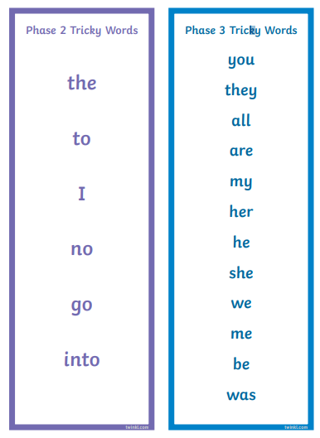
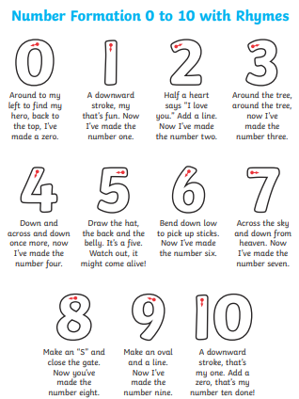

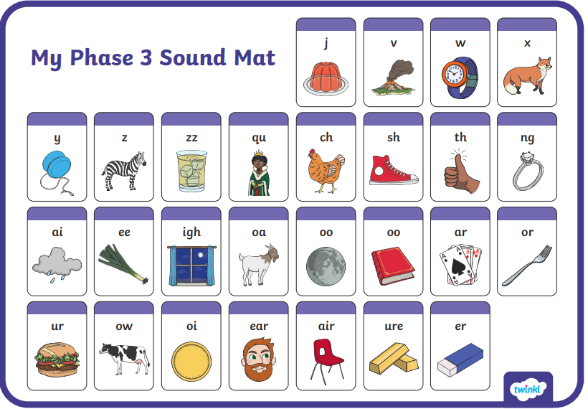
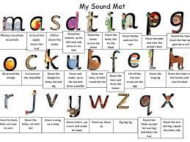
https://www.phonicsbloom.com/uk/game/list/phonics-games-phase-2 have some great Phase 2 phonics interactive games too!

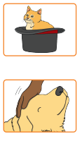
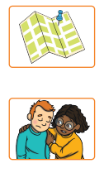

Write a caption about one of these pictures:

