ECaT
This half term we will continue looking at the topic ‘Antartica’ but this half term we will have a history focus thinking about the famous explorer Shakleton. Our ECaT for this half term will be closely linked to this as well as other areas of our learning (please see termly overview). Over the half term please complete at least 2 of these activities and either send in photos via Dojo or bring in what you have been up to. Please feel free to come up with some of your own ideas too- we have lots of very creative parents with fabulous ideas; but as always there is no pressure- just enjoy time with your children and sharing a special time where children’s communication is at the heart of what you are doing.
Please continue to do daily reading to support the teaching of our Systematic Synthetic Phonics Program. Children should aim to read 3 times a week minimum with the goal of daily reading
Many thanks Miss Goold
Crafty Ideas:  - What Easter crafts can you make? Your own bonnet/egg/basket?  - Choose one of your favourite well known books and make our class some puppets for our reading corner so you can tell the story together!  - Make your own cress head pots.  - Design your dream garden. What plants would be in there?  - Make a healthy snack. Maybe you could use some of the vegetables from ‘Oliver’s Vegetables’.  - Design and make your own adventure aeroplane. | Writing/Reading ideas:  - Have a go at writing some words with the sounds ‘ai’ ‘ee’ ‘igh’ in. Can you find any of these words around the house?  - Draw a picture of the job you would like to have when you are a grown up and write a sentence telling us about it.  - Practice your phonics flashcards. Who will be the teacher- you or your grown up?  - Play the phonics games linked below.  - Make a den and read your book inside!  - Have a go at spelling your tricky words. | Maths ideas:  - Have a go at writing the numbers to 10.  - Draw a part part whole model (picture below) and have a go at making different number bonds to 10.  - Measure different liquids in cups. Which has the most?  -Go on a hunt around your house and find out which items are heavier/lighter.  - Ask your grownups to give you addition sentences within 10. You could use pasta as counters to help you work it out. | Songs and Dances:  https://www.youtube.com/watch?v=RE5tvaveVak&vl=en  https://www.youtube.com/watch?v=0VLxWIHRD4E  https://www.youtube.com/watch?v=K6DSMZ8b3LE  https://www.youtube.com/watch?v=D3HopSE8M5g  Some of our Focus books:  -Oliver’s Vegetables  -Supertato  -We are going on an egg hunt  -In every house on every street.

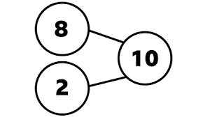
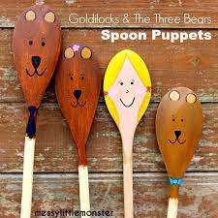
Number bonds to 10 are 2 numbers you can add together to make 10.

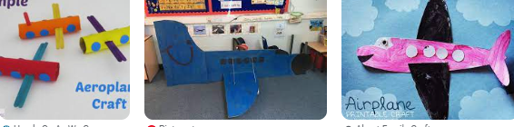

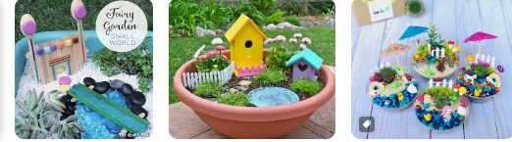
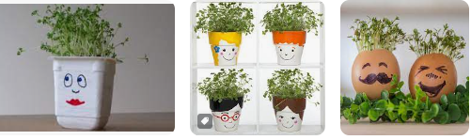
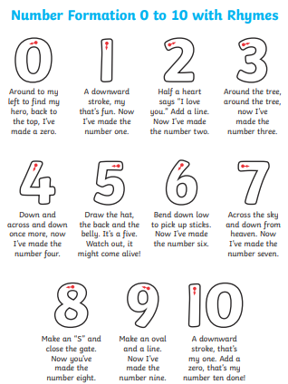

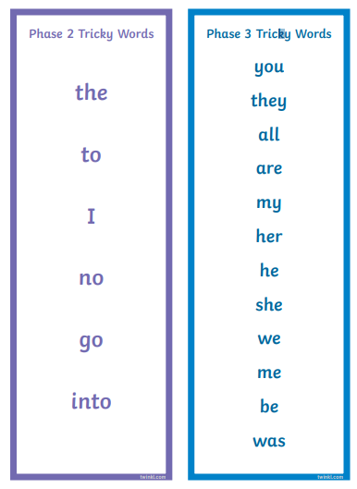

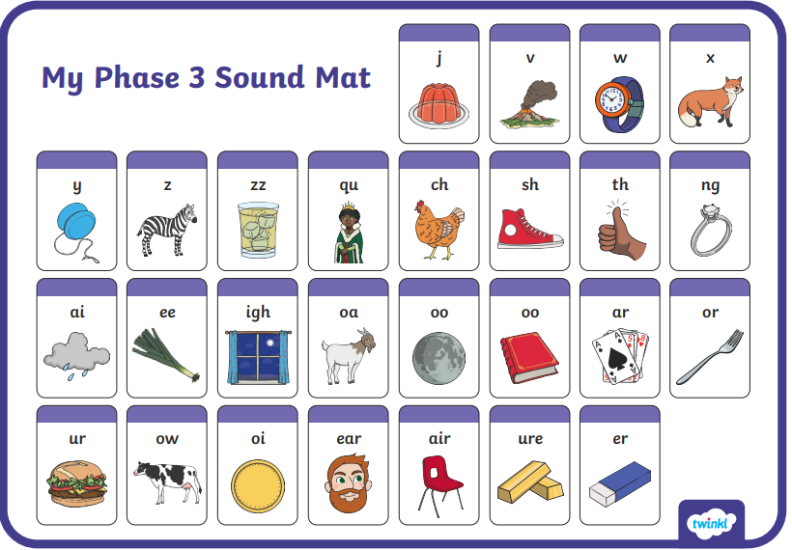
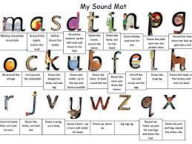

https://www.phonicsbloom.com/uk/game/list/phonics-games-phase-2 have some great Phase 2 and 3 phonics interactive games too!

