ECaT
This half term we will continue looking at the topic ‘I do like to be beside the seaside”’ Our ECaT for this half term will be closely linked to this as well as other areas of our learning (please see termly overview). Over the half term please complete at least 2 of these activities and either send in photos via Dojo or bring in what you have been up to. Please feel free to come up with some of your own ideas too- we have lots of very creative parents with fabulous ideas; but as always there is no pressure- just enjoy time with your children and sharing a special time where children’s communication is at the heart of what you are doing.
Please continue to do daily reading to support the teaching of our Systematic Synthetic Phonics Program. Children should aim to read 3 times a week minimum with the goal of daily reading
Many thanks Miss Goold
Crafty Ideas:  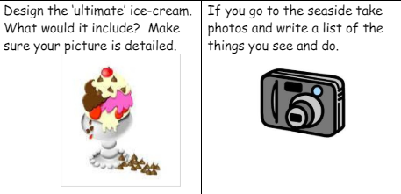  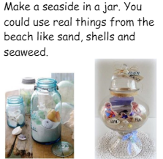  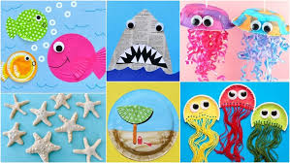  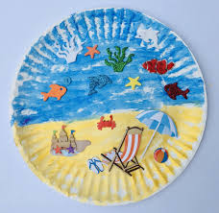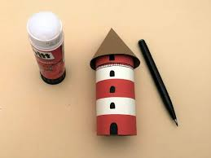 | Writing/Reading ideas:  - Have a go at writing some words with the sounds “oo” “oa” “or” “oi” in. Can you find any of these words around the house?  - Draw a picture of the seaside or an animal that lives at the seaside and write a caption about it. These might end up on our wall!  - Practice your phonics flashcards. Who will be the teacher- you or your grown up?  - Play the phonics games linked below.  - Make a den and read your book inside!  - Have a go at spelling your tricky words. | Maths ideas:  - Have a go at writing the numbers to 20.  - Draw a part part whole model (picture below) and have a go at making different number bonds to 10.  -Can you order numbers to 20.  -Can you find any 2D or 3D shapes around your house? What are they called? | Songs and Dances:  https://www.youtube.com/watch?v=1nJ5VbyD6tY  https://www.youtube.com/watch?v=guNdJ5MtX1A  https://www.youtube.com/watch?v=kcHyyuGjuk0  https://www.youtube.com/watch?v=oe_HDfdmnaM  https://www.youtube.com/watch?v=a78-VKcdNNc  Some of our Focus books:  -Sharing shell  -Billy’s bucket  -Shark in the park  -Commotion in the ocean

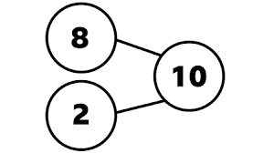
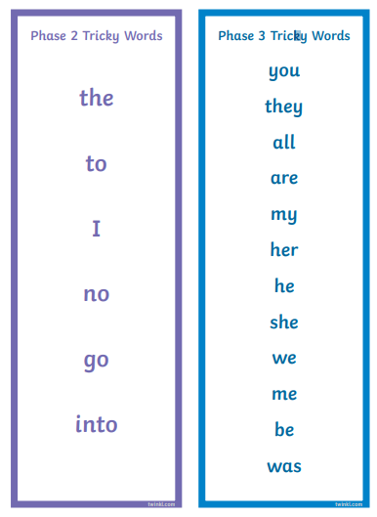
Number bonds to 10 are 2 numbers you can add together to make 10.


