South Wingfield
Autumn 1 KS1 Homework Tasks
Daily task:

Reading, reading and more reading.
You should aim to read 5 times a week to a grown up.
Weekly tasks:

Practise your spellings (refer to the attached document for creative ways to learn them).
Complete the weekly Spelling Shed task.
Year 1s-Practice your number bonds to ten.
Year 2s- Learn to recite your times tables, individual tables have been selected for you on TT Rockstars.

Topic homework options- Choose at least two to complete by the end of the half term.
Science | Design & Technology | Creative | History/Geography | English | Maths
Go on a materials hunt! What materials can you find?  OR  Sort some recycling with your grown ups! What materials can you see? | Design your own toy!  OR  Design a house for your mouse/other toy! What materials would be suitable? | Paint/draw a picture of you and your family to show your friends.  OR  Make a collage using different materials of a toy that you have at home.  OR  Design a front cover for a new book! | Interview your grandparents about what toys they used to play with when they were younger? Have you got any photos? Could you write a description about them? How have they changed?  OR  Talk to your grown up about what your favourite toy was when you was a baby. | Write a fact file about you.  OR  Draw a picture of your family and write a few sentences to describe them.  OR  Practice your phonics flashcards/have a go at some of the Phase 3 phonics games on phonicsbloom.com | Practice number formation for your numbers to 20.  OR  Ask a grown up to write you some addition or subtraction sentences within 10 for you to have a go at.  OR  Practice your number bonds to 10.

Y1 Y2
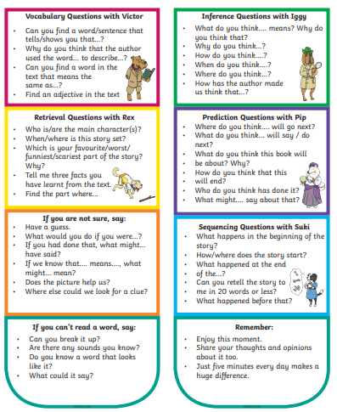 | 

