South Wingfield
Summer 1 KS1 Homework Tasks
Daily task:

Reading, reading and more reading.
You should aim to read 5 times a week to a grown up.
Weekly tasks:

Practise your spellings (refer to the attached document for creative ways to learn them).
Complete the weekly Spelling Shed task.
This half term there is a BIG push for Year 1’s to practise their phonics! Please use the phonic games below and flashcards given out to support your child at home.
Year 1s-Practise your number bonds to ten.
Year 2s- Learn to recite your times tables, individual tables have been selected for you on TT Rockstars.

Topic homework options- Choose at least two to complete by the end of the half term.
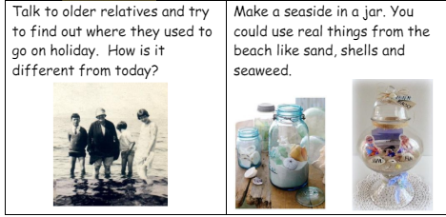
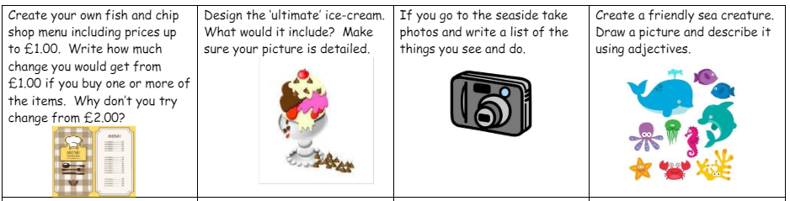
Can you sort photographs/toy animals that you have at home into animal groups?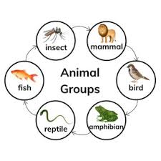
Research a coast near you? What human and physical features can you name? 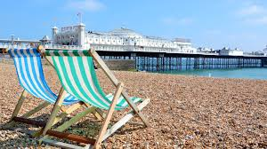

Y1 Y2
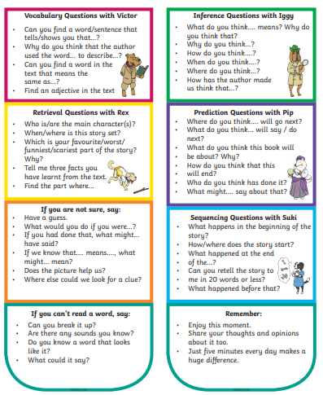 | 

