SPAG  Term 1  Verbs  Compound nouns  Prefixes – dis, mis, un  Subordinating conjunctions  Inverted commas  Term 2  Adverbs, time, place, cause  Prefixes – in  Suffixes – ation  Co-ordinating conjunctions  Organisational devices  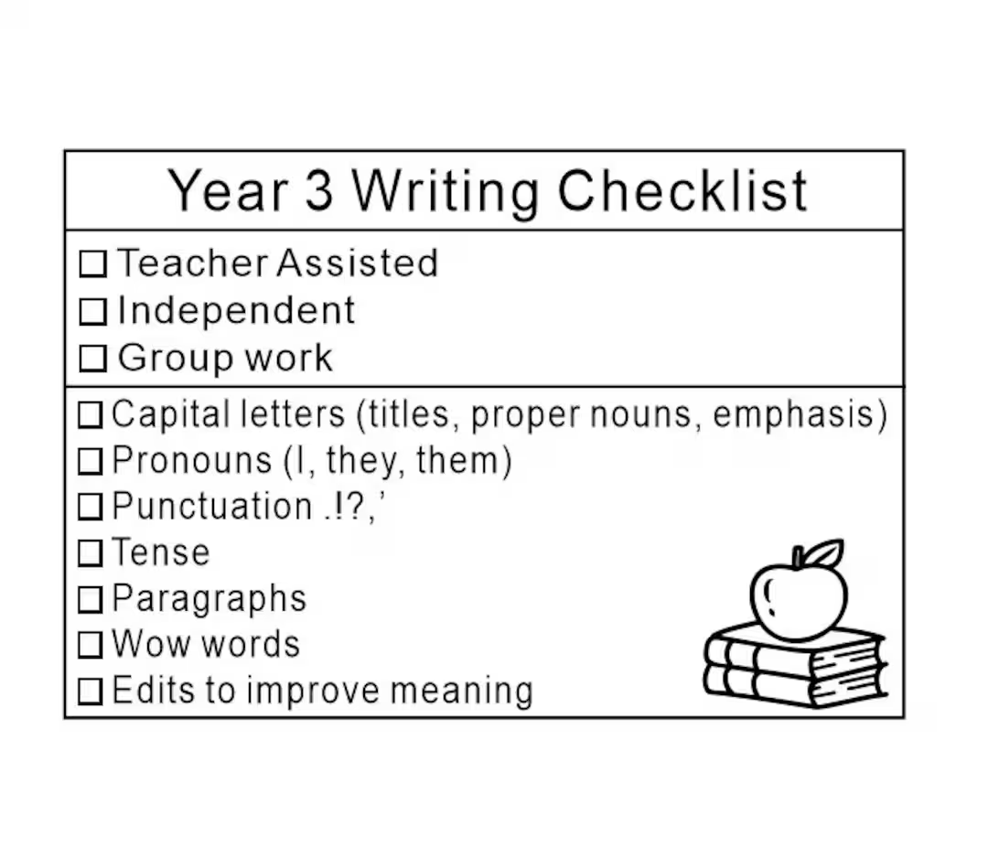 | English  - Stories on a theme – Sea stories  - Explanation  - Poetry expressing emotions  - Classic fiction – Wind in the Willows  - Reports  - Poetry – performance poetry  This term we will be reading…  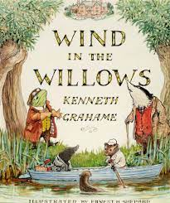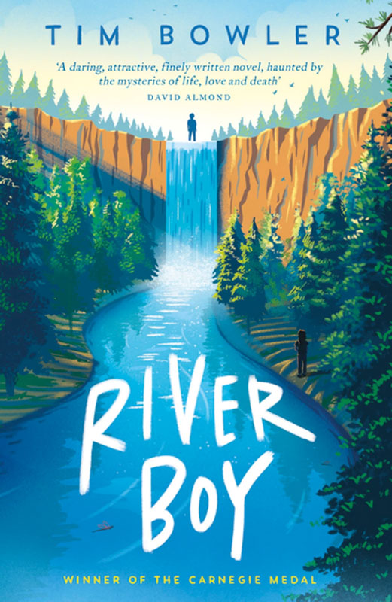 | Topic: Mountains, rivers and coasts….how do they affect us?  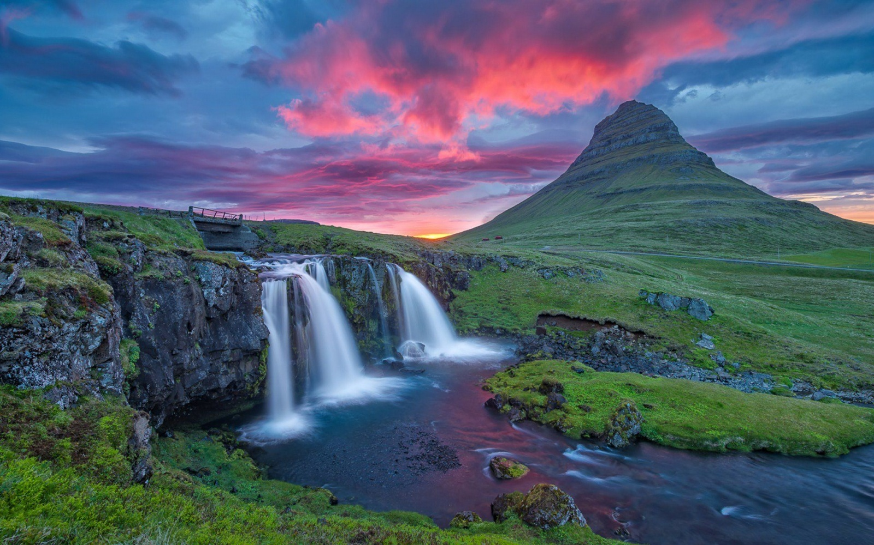  Children will learn about human and physical geography and what mountains, rivers and coasts actually are, some of the forces that help create and shape these important features, and the effects they have on the world around them. Children will learn about the climates, human interactions, and lifestyles shaped by the mountains, rivers and coasts of the world.
Maths  Multiplication & Division  Perimeter and length  Fractions  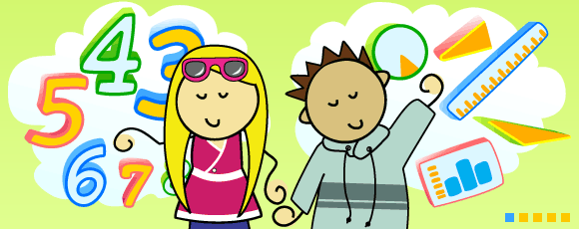  Times tables:  Weekly tests Fridays  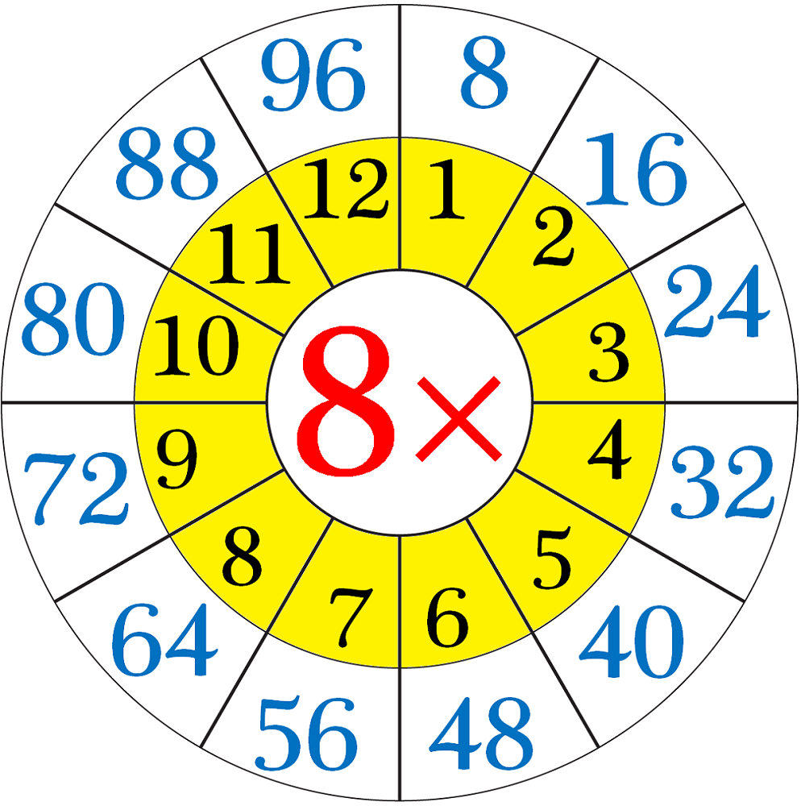 | Science: Term 1 - Electricity?  Children will learn about common electrical appliances and how to construct simple series circuits. They will become familiar with the key words linked to the topic and how to apply them appropriately. Children will learn about cells, wires, bulbs and buzzers and about the different types of switches. They will be able to troubleshoot and identify whether or not a bulb will light in a simple series circuit and be able to identify a complete circuit. The children will also learn about conductors and insulators and know that metals are very good electrical conductors.  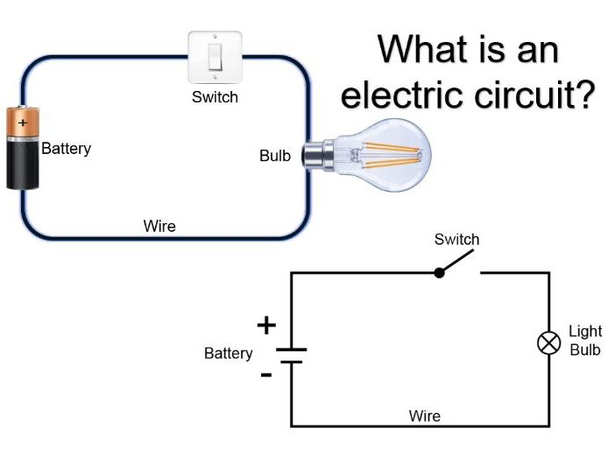  Science: Term 2 -Plants  Children will learn the names of different parts of plants, and the jobs they do. The children will work scientifically and collaboratively to investigate what plants need to grow well, and will present their findings to their classmates. Furthermore, they will have chance to predict what will happen in an exciting investigation into the transportation of water within plants. They will work in a hands-on way to identify the parts of a flower, and will explore the different stages of the life cycle of a flowering plant. | PSHE  We will look at considering factors to keep our selves safe; considering risk factors; thinking about places and situations that are safe and unsafe as well as relationships and recognising peer pressure  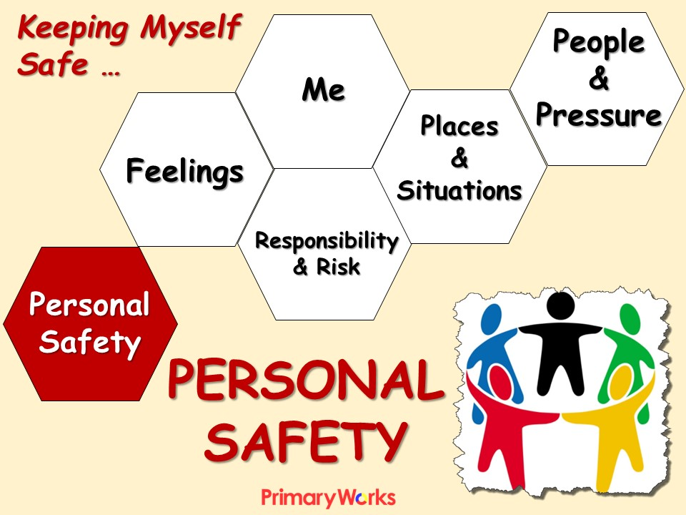
French

Colours and size

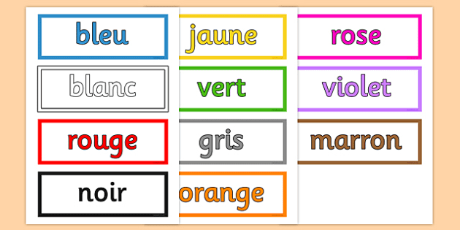
PE  Amber Valley will continue to take one PE session and we will be exploring gymnastics. The second session is on Friday afternoons.  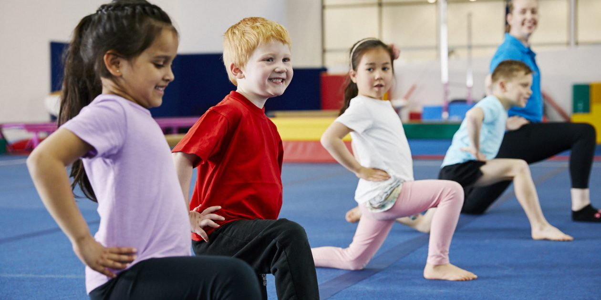 | Art/DT  Collage  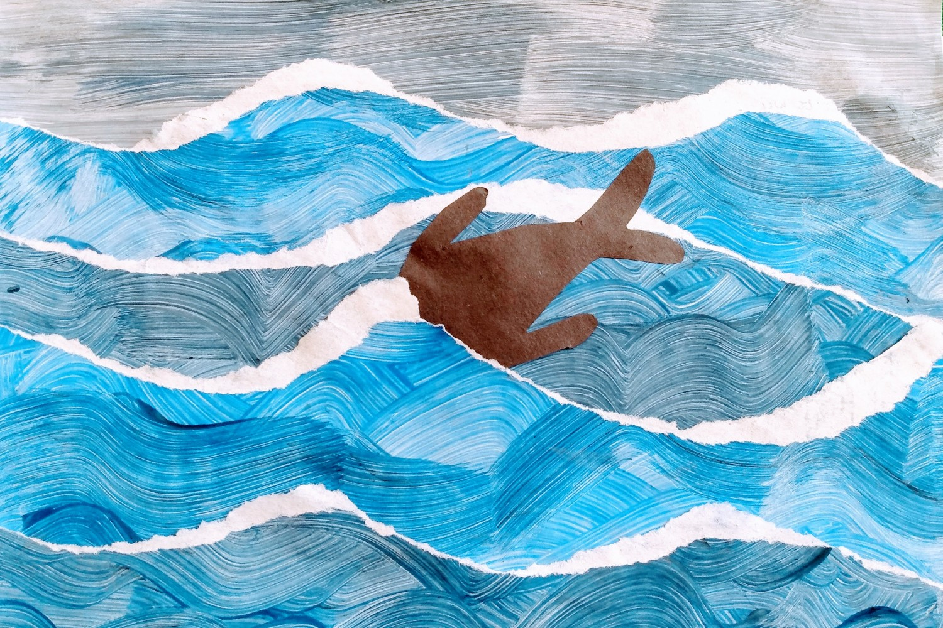  Sculpture  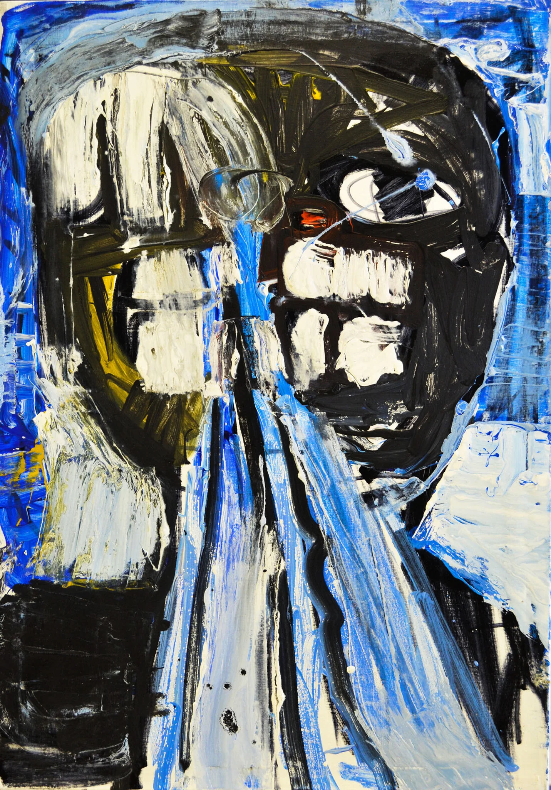 | Music  We will be exploring notation and composition. Chn will make their own instruments and compose their own music to African and Christmas themes.  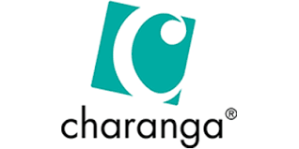
RE

Term 1: Why is the bible important to Christians? (Cont) (Christians, Christianity)

This topic on the Bible will look at the Bible in Christianity, its origins, its role as a sacred religious text and how it is used by Christians around the world. Children will consider the authorship of the Bible, discussing the Christian belief that it is the Word of God whilst finding out about different writers of books in the Bible. They will discuss the different text types used in the Bible and explore a story in greater depth. Children will apply their learning to consider an item or book that is sacred to them, and reflect on how respect can be shown to things that are sacred to others.

Term 2: Why do people pray?
( Exploring Worship Opening Up creativity Christians, Hindus, Muslims)

Pupils will explore different religious and spiritual ways of life about prayer: the practice, symbols, words and significance of prayer are studied alongside some key beliefs about prayer, so that pupils can develop thoughtful ideas and viewpoints of their own about prayer. The investigation implements the principal aim of RE, which is to engage pupils in systematic enquiry into significant human questions which religion and worldviews address, so that they can develop the understanding and skills needed to appreciate and appraise varied responses to these questions, as well as develop responses of their own.

