Maths | Out and about | English
- Go to a travel agents or research holidays to India online. Budget how much it would cost to go on holiday with your family.  - Find out how many days/hours from June to July.  - Find out how many miles from London to a place of your choice in India and work out how many kilometres that would be if 5 miles = 8 kilometres .  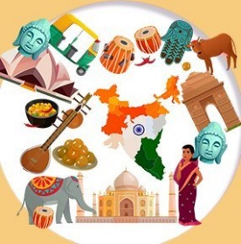 | - Visit your local library and find some non-fiction books about India.  - Find at least five different leaves stick them on paper and draw them.  - Visit a travel agent for a holiday brochure. Design a leaflet to encourage tourism to India.   | - Produce a short non - fiction leaflet all about summer  - Write a themed poem or story about summer  - Use the words’ Summer-time’ to create an acrostic poem.  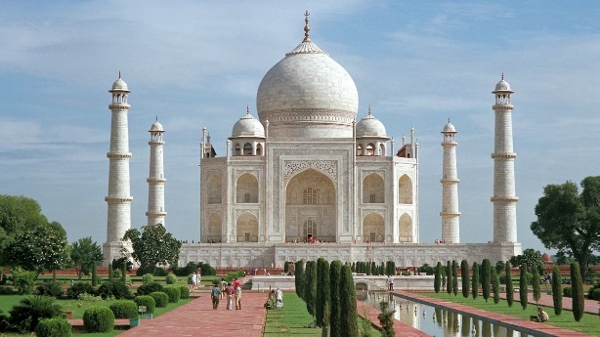
Working with others |  | Art and craft
- Find or write some seasonal themed jokes and share them with friends or family members!  - Look at different Indian flowers with help, find out their names.  - Create a summer time themed board or card game and teach friends or family members how to play.  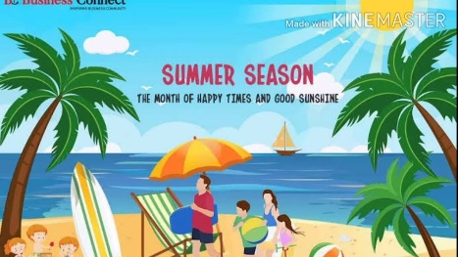 |   Homework Choice Grid  Please complete 2 tasks of your choice for your homework. | - Create a picture of a countryside in summer using different textures and materials.  - Create a model of a person dressed in a national costume from India.  - Design and make a model of an Indian elephant or tiger.  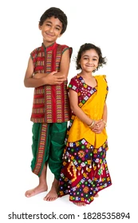
Let’s get technical | Health and wellbeing | Social studies
- Use a computer to research interesting places to visit in India create a poster with captions.  - On a computer design and make a postcard that could be sent from India.  - On a computer create a picture dictionary of at least 10 things and write the word in Hindi.  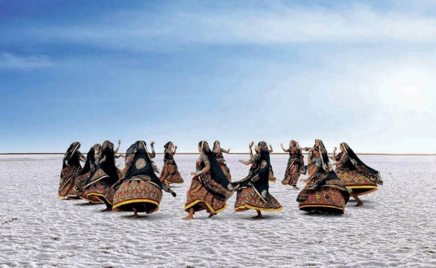 | - Find and make some Indian recipes.  - Write a menu for a feast from India.  - Research different charities that support people in India.  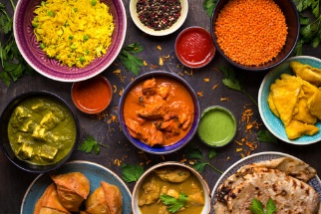 | - Design an information poster about how to look after the English countryside.  - Design a fact file about animals found in India.  - Draw or trace a map of India and mark some cities or large towns.  

