Class 5 Owls Term 3 Overview Cycle B
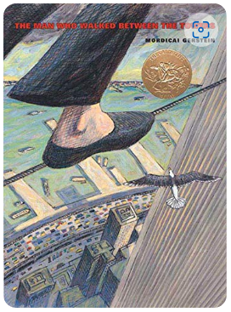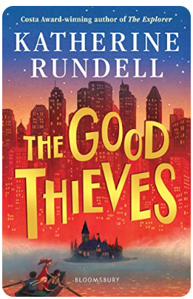

English  Narrative linked to The Man Who Walked Between the Two Towers (3 weeks)  Newspaper Report linked to The Man Who Walked Between the Two Towers (3 weeks)  Information Text (How did the Native Americans use the buffalo?) (3 weeks) | Maths  Year 6  Fractions  Equivalent Fractions  Compare and Order Fractions  Add and Subtract Fractions  Multi-Step problems involving fractions  Year 5  Fractions  Equivalent Fractions  Improper to mixed  Mixed to improper  Compare and Order Fractions  Add and Subtract fractions
Geography  What are the key geographical features of the UK and the my region (East Midlands)?  What is the geography of the North American continent? (Countries, capital cities, oceans, biomes)  What is the USA? (Regions, states, cities, landmarks)  What is the main economic activity of states in the Western United States?  What is the water cycle?  What are rivers? (including comparison case study in the Western United States and their region.) | Science  Electricity  Children will be taught to:  - associate the brightness of a lamp or the volume of a buzzer with the number and voltage of cells used in the circuit  - compare and give reasons for variations in how components function, including the brightness of bulbs, the loudness of buzzers and the on/off position of switches  - use recognised symbols when representing a simple circuit in a diagram
Design and Technology  Kapow – Structures  To explore how to reinforce a beam (structure) to improve its strength.  To build a spaghetti truss bridge.  To build a wooden truss bridge.  To complete, reinforce and evaluate my truss bridge. | PE  Gymnastics
Music    Make You Feel My Love  The Fresh Prince of Bel Air | PSHE  Relationships  Reflect on qualities in a relationship  Strategies to resolve disputes and reconcile differences  Stability and love  Diversity Matters  Diverse and fair communities  Individuality, stereotypes and discrimination law
RE  U2.2 (Believing) What would Jesus do?  U2.3 (Expressing) If God is everywhere, why go to a place of worship? | Computing  Skills Showcase  - Pupils who are secure will be able to:  - Evaluate code, understanding what it does and adapt existing to code for a specific purpose. Debug programs and make them more efficient using sequence, selection, repetition or variables.  - Design appropriate housing for their product using CAD software, including any input or output devices needed to make it work.  - Create an appealing website for their product, aimed at their target audience which explains what their product is and what it does, using persuasive language.  - Create an edited video of their project, articulating the key benefits.  - Describe and show how to search for information online and be aware of the accuracy of the results presented.
French  Kapow – Clothes Getting Dressed  • To recognise and use vocabulary relating to clothing  • I can pronounce new vocabulary  • I can build a statement from this new vocabulary  • I understand and can use appropriate determiners: un, une, des, mon, ma, mes  • To add colour adjectives, adapting the suffix in accordance with gender  • I know that I need to add an ‘e’ to the adjective if it is describing a feminine (la/une) word  • I know to put the colour adjective after the noun (object)  • I can recognise the written form of new words  • To understand adjectival position and agreement for gender and number  • I know that colour words come after the noun (object) they describe and that size words come before the noun (object) they describe  • I know that I need to add an ‘s’ to the adjective if it is describing a plural word.  • I can listen to someone describe an outfit and pick the picture they are describing  • To express an opinion (like/dislike)  • I can say if I like or dislike an outfit  • I can use a range of adjectives to describe clothing  • I can label items of clothing using nouns and adjectives  • To describe an outfit using adjectives correctly  • I can say what someone is wearing  • I know whether to use il or elle  • I know when adjectives need to go before or after the noun  • I can put the right ending on an adjective to make it match (agree with) its noun | Art and Design  Painting and Mixed Media – An artist study  To understand how to analyse a famous painting.  To understand how to find meaning in painting.  To apply drama techniques to explore the meaning of a painting.  To apply interpretation skills to analyse and respond to an abstract painting.  To understand how art can tell stories or portray messages.  To develop starting points for creative outcomes.  To demonstrate an understanding of painting techniques to make personal choices.

