South Wingfield
Spring 1 KS1 Homework Tasks
Daily task:

Reading, reading and more reading.
You should aim to read 5 times a week to a grown up.
Weekly tasks:

Practise your spellings (refer to the attached document for creative ways to learn them).
Complete the weekly Spelling Shed task.
Year 1s-Practise your number bonds to ten.
Year 2s- Learn to recite your times tables, individual tables have been selected for you on TT Rockstars.

Topic homework options- Choose at least two to complete by the end of the half term.
Science | Design & Technology | Creative | History | English | Geography
Research a type of animal, think about which animal group it belongs to. What diet does it have?  OR  Label parts of your own body! Which senses do they use?  OR  Plant something in your garden and observe the changes. Could you plant something that could be brought into school and added to our school garden? | Make a traditional African necklace.  OR  Construct an African drum. Maybe you could learn to play a song on it! | Make an animal mask.  OR  Create an animal print!  OR  Design a postcard that you could send from Africa. | Look at traditional African patterns and outfits. | Write a postcard to a friend from Africa.  OR  Write a fact file about an African animal.  OR  Write a description using powerful adjectives about Africa or an African animal. | Draw a map of Africa with some African animals on.  OR  Use an atlas to find out where abouts Africa is.

Y1 Y2
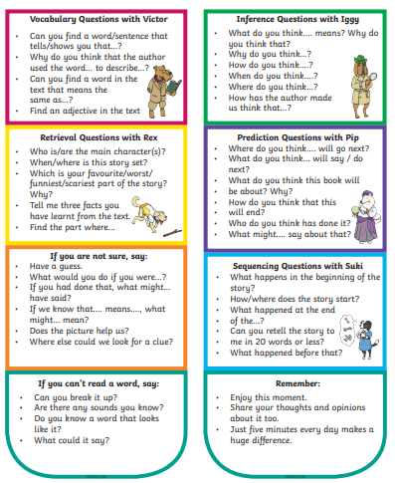 | 

