ECaT
This half term our focus topic is ‘Africa’ and lots of the learning that will be taking place will be focused around this. Our ECaT for this half term is all linked to the topic of Africa. Over the half term please complete at least 2 of these activities and either send in photos via Tapestry or bring in what you have been up to. Please feel free to come up with some of your own ideas too- we have lots of very creative parents with fabulous ideas; but as always there is no pressure- just enjoy time with your children and sharing a special time where children’s communication is at the heart of what you are doing.
Please continue to do daily reading to support the teaching of our Systematic Synthetic Phonics Program.
Many thanks Miss Goold
Crafty Ideas:  - Make an African animal mask.  - Create your own traditional African necklace.  - Construct an African drum. Maybe you could learn to play a song on it!  - Built an African house!  (See pictures below for inspiration!) | Writing/Reading ideas:  - Write your name in rainbow colours.  - Write the names of some animals you know about.  - Write a short caption to describe an African animal (It is big.)  - Play the phonics games linked below.  - Make a den and read your book inside!  - Have a go at spelling your tricky words. | Maths ideas:  - Have a go at writing the numbers to 5.  -Show your grown up different ways to make the number 5.  -Go on a nature hunt. How many pinecones can we find- what is one more/less?  -Look around your house to see if you can find the numbers to 5.  -Measure how long something is using blocks/Lego you have at home. | Songs and Dances:  https://www.youtube.com/watch?v=Pq8KhHlM-S0  https://www.youtube.com/watch?v=nNbZhIv0szM  https://www.youtube.com/watch?v=eBoyh1BEF_o  Some of our Focus books:  -Mama Panya’s Pancakes  -Goldilocks and the Three Bears  - All Board the Bobo Bus.  -The Book of Nursery Rhymes.

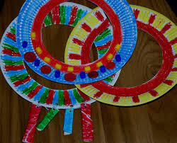
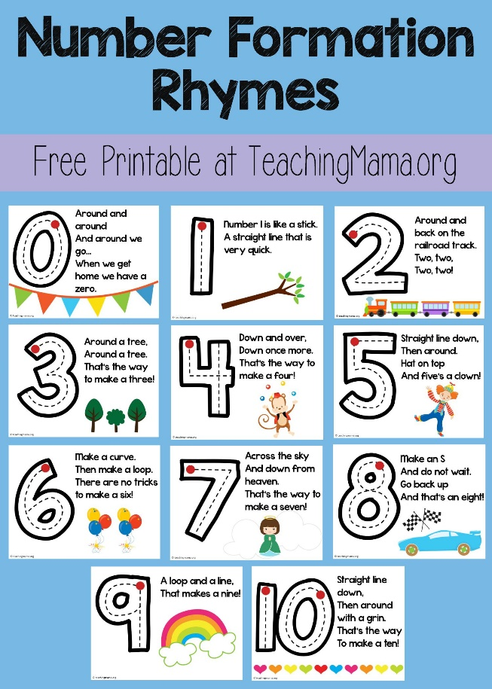
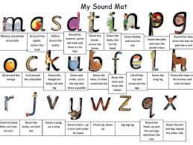
https://www.phonicsbloom.com/uk/game/list/phonics-games-phase-2 have some great Phase 2 phonics interactive games too!


