SPAG/English  SPAG- Children will be learning a range of techniques that link to our style of writing including: adverbs, fronted adverbials, apostrophes. They will also be learning their spelling rule for the week and completing work based around this.  English- Children will be continuing their English from last half term they will be writing a diary entry. They will be putting themselves in the shoes of the main character from our book Dragon Mountain and writing a diary entry all about their adventures. After that they will be using inspiration from our book dragon mountain and writing their very own myth or legend.  Reading- Our topic book this half term is Dragon Mountain  Our reading for pleasure book this half term is The House at the Edge of Magic  Our poetry book this half term is Sensational  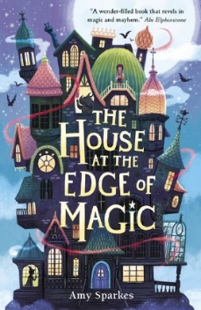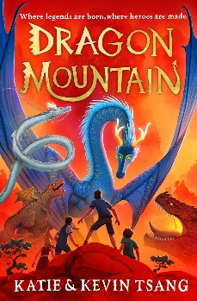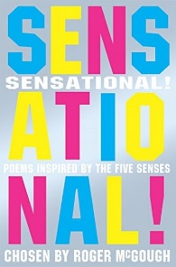 |  | History- China  Last term as a class we looked at the geography of China including things like the economy, landmarks etc. This half term we will be focussing on the history of China. The children will learn who the Ancient Shang people were, where and when they lived, using maps and atlases to locate Shang cities. They will also learn about the role of the king, the religious beliefs and rituals of the Shang people and how oracle bones were used in divination ceremonies. The children will also examine a range of Shang artefacts and draw conclusions about what they can teach us. The unit ends with a close look at the remarkable discovery of the first intact Shang tomb which belonged to the military general and high priestess Fu Hao.  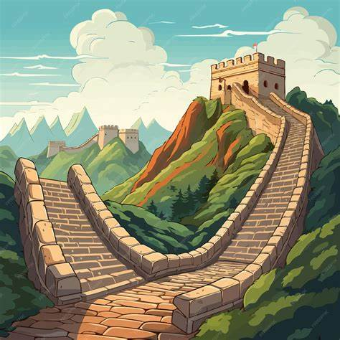
Maths  Children will be continuing their topic of fractions focussing on equivalent fractions, mixed numbers, adding and subtracting fractions before moving onto our topic of decimals where children will be looking at tenths and hundredths on a place value chart.  Times Table of the Term (Children’s TT Rockstar’s test on a Friday will be based on this times table) – Y4- 8x table Y5- Mixed times tables and square numbers | Science Y4 (Taught by Miss Wareham)  Electricity  - Appliances that use electricity  - Building and drawing circuits  - What’s gone wrong?  - Conductors and insulators  - Conductivity within a circuit  Energy  - What is energy?  - How can we reduce our energy usage?   | PSHE- Exploring Emotions  - Exploring different emotions  - Widen vocabulary to describe feelings and their intensity  - What supports good mental and physical health  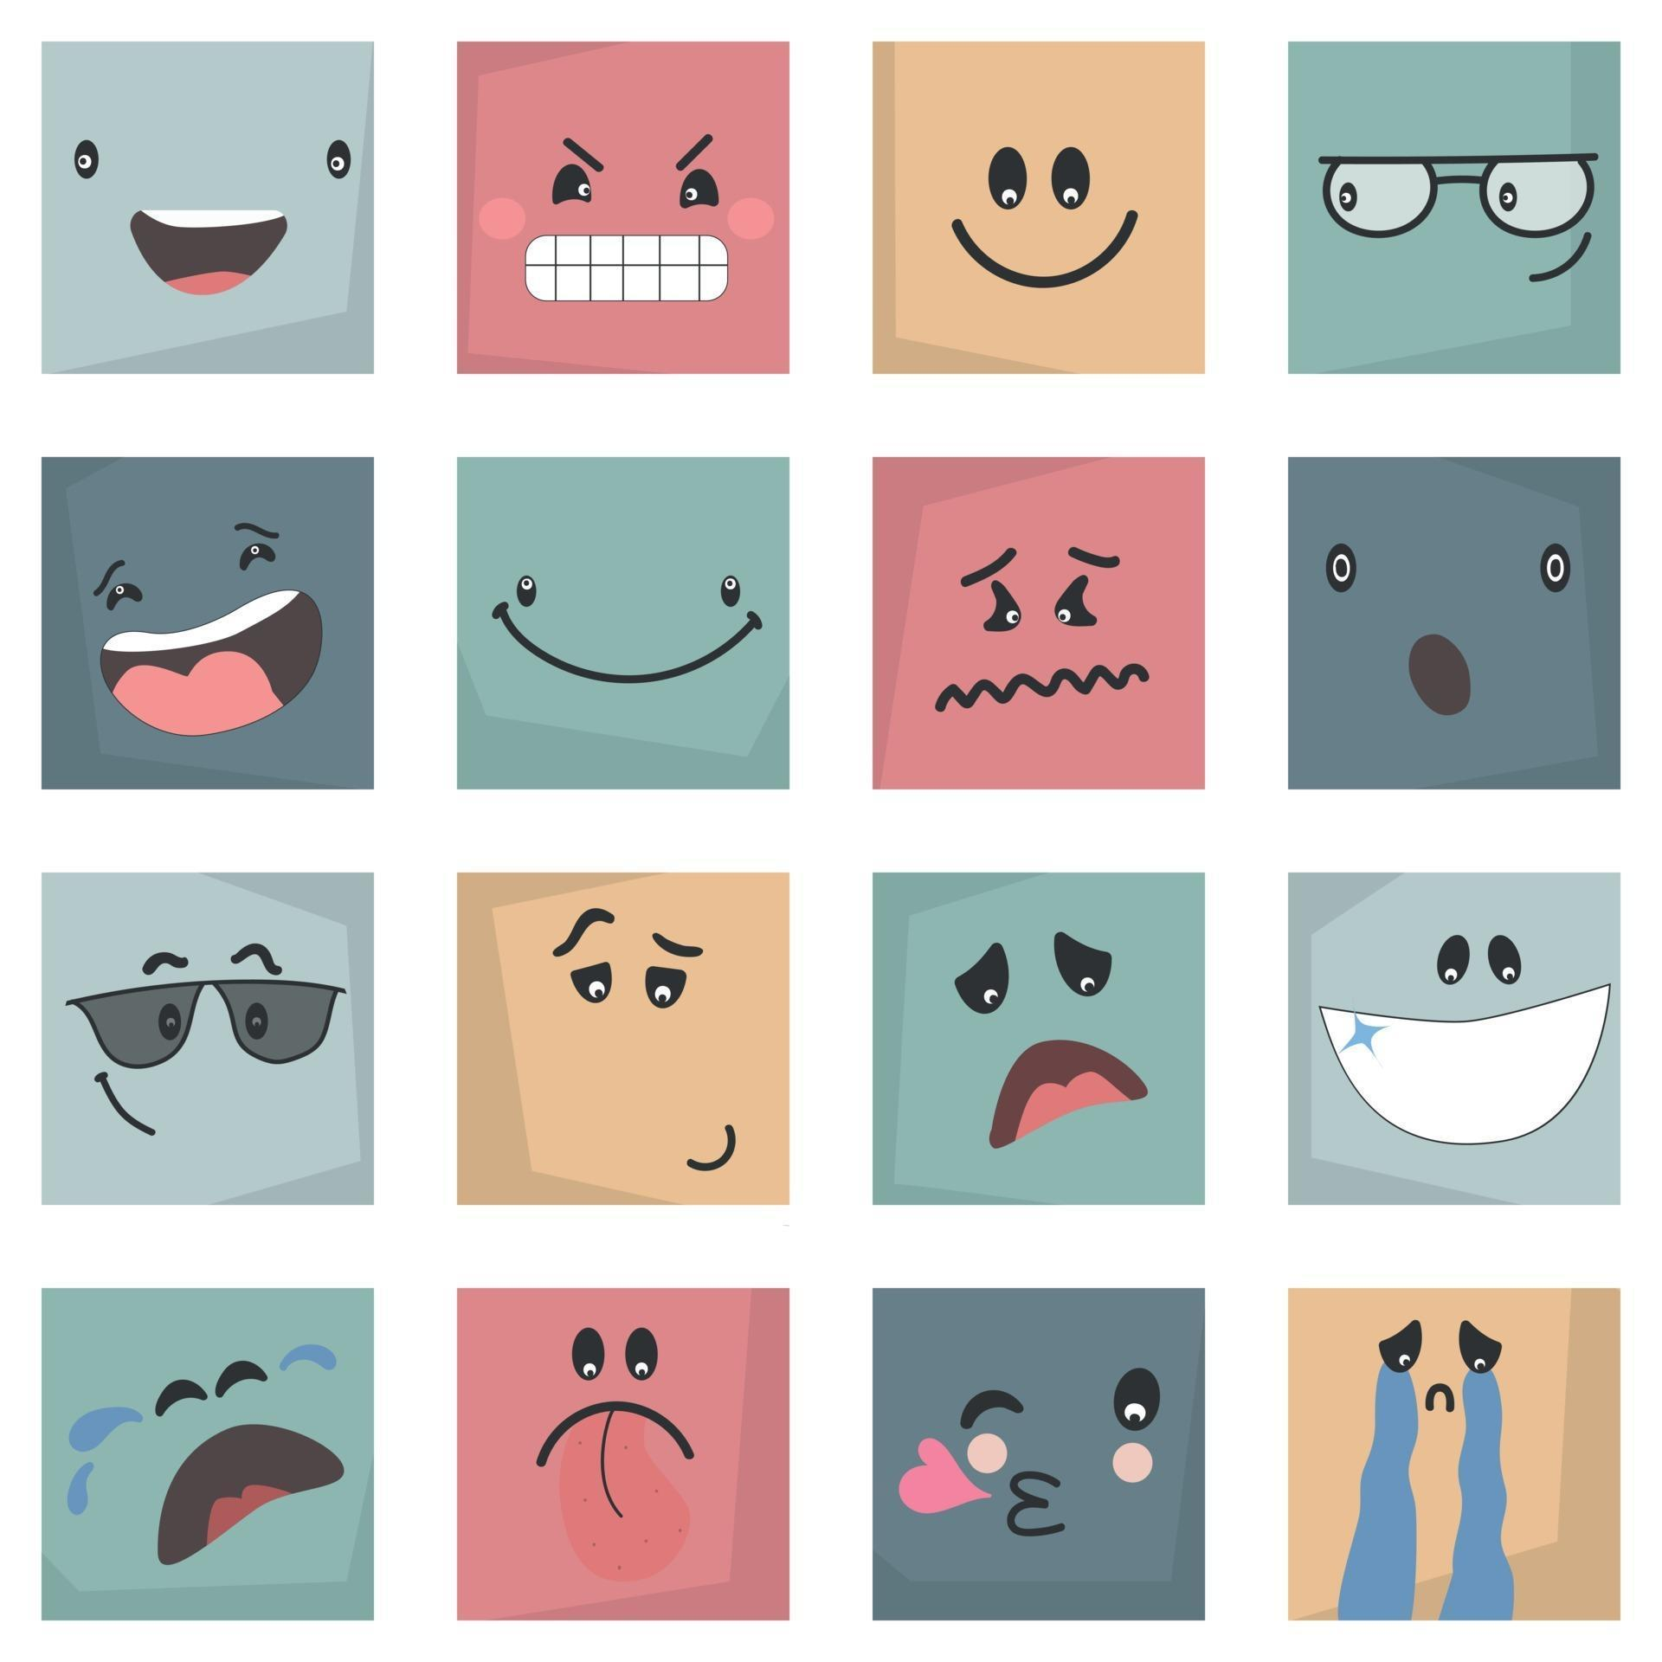
PE  Children will be having a weekly PE session with AVSP on a Tuesday. They will also be continuing their swimming on a Wednesday afternoon. For Spring 2 we are lucky enough to have a special visitor who will be coming in and delivering an additional dance PE session to the children on a Wednesday morning.  PE kit needs to be worn on a Tuesday and Wednesday please. We have a PE uniform policy that needs to be followed, please see the newsletter for more information. | DT- Making a slingshot car  - Work independently to produce an accurate, functioning car chassis.  - Design a shape that is suitable for the project.  - Attempt to reduce air resistance through the design of the shape.  - Produce panels that will fit the chassis and can be assembled effectively using the tabs they have designed.  - Construct car bodies effectively.  - Conduct a trial accurately and draw conclusions and improvements from the results.  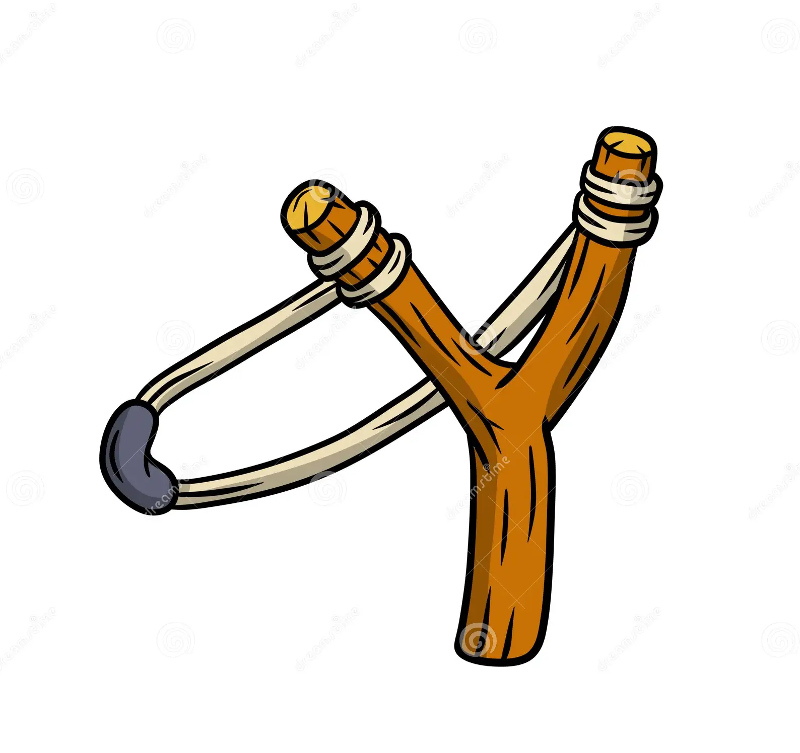 | French- Verbs in a French week  - Attempt to read new verbs aloud with confidence and mostly accurate pronunciation.  - Create an opinion phrase using one of the new verbs.  - Work together to visually and orally present a verb in at least three different forms, with the appropriate pronoun.  - Work together to build a verb spinner and use it to generate appropriate phrases.  - Recognise and recall different parts of verbs avoir and être.  - Create an original short text, correctly adapting a range of verbs to their appropriate form.  
Computing- Online Safety  - Describe how to search over multiple platforms and be aware of the accuracy of the results presented.  - Describe some of the methods used to persuade people to buy online.  - Explain the difference between fact, opinion and belief and recognise these online.  - Explain what a bot is and give examples of different bots.  - Explain some positive and negative distractions of using technology and small strategies for reducing the time spent on technology.   | RE- Why do we hurt?  In this Hurt and Healing unit, children will explore concepts of hurt and healing and how people cope when faced with difficult situations. They will begin the unit by thinking about what is meant by hurt. They will then look in depth at a series of Bible stories featuring themes of hurt and healing. Children will then look at the Buddha’s teaching on suffering. The next lesson helps children learn more about Humanism and how Humanists make sense of suffering. In the final lesson, children compare and contrast the different views they have learnt about.  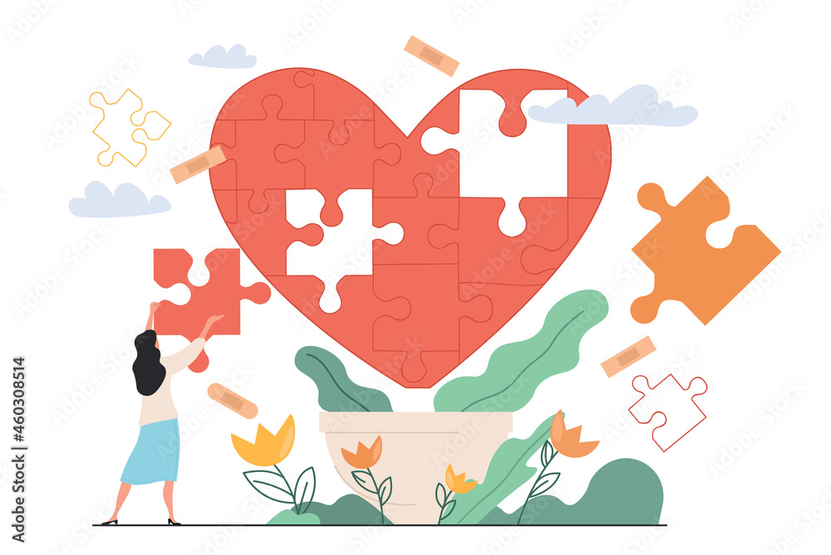 | Music- Charanga  Charanga Topic- Following the topic, food glorious food (Oliver)  

