SPAG/English  SPAG- Children will be learning a range of techniques that link to our style of writing. They will also be learning their spelling rule for the week and completing work based around this.  English- Children will be writing a newspaper report based around their topic of space. They will be learning all the features of a newspaper report and writing their very own report about the first woman to enter space.  Reading- Our topic book this half term is A galaxy of her own  Our reading for pleasure book this half term is Earth is Big  Our poetry book this half term is I’m the seed that grew the tree  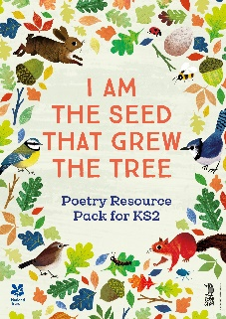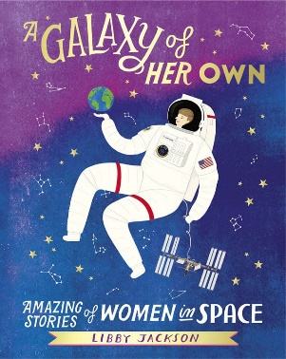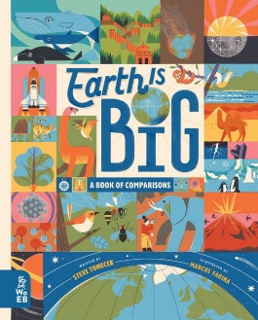 |  | History- The Space Race  In this topic children will look at developments in space exploration, from the invention of the telescope to the space race and up to modern space travel. They will also learn about the first black woman in space: Mae Jemison.  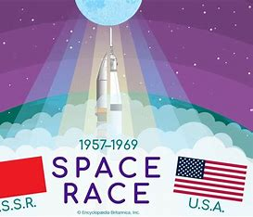
Maths  Children will be starting a topic all about decimals and percentages, they will be looking at representing a variety of numbers, figuring out percentages, rounding decimals and also adding and subtracting decimals.  Times Table of the Term (Children’s TT Rockstar’s test on a Friday will be based on this times table) Both year groups will be doing mixed times tables up to 12x.  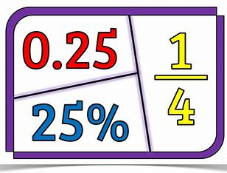 | Science Y4 (Taught by Miss Wareham)  Data Collection  - Analysing data  - Making conclusions  Habitats  - Living things  - Classification key plants  - Classification key animals  - Human impact on habitats  Deforestation  - What is deforestation?  - What is the impact on the world?  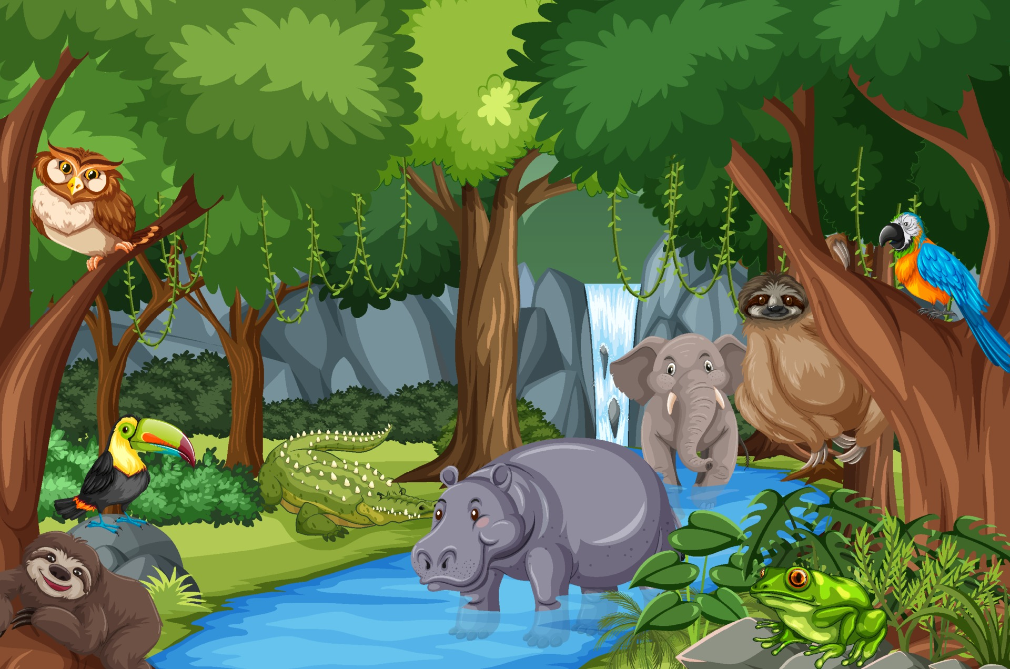 | PSHE- Changes  - Recognising that feelings can change over time, and range in intensity.  - Identifying the everyday things that affect feelings, and the importance of expressing how we feel.  - Using a varied vocabulary when talking about feelings.  - Recognising the signs when someone may be struggling and understand how to seek support.  - Discussing change and loss, and how these can affect feelings, thoughts and behaviours.  - Identifying strategies for dealing with emotions, challenges and change. Identifying strategies to manage transitions between classes and key stages.
PE  Children will be having a weekly PE session with AVSP on a Tuesday. Both their dance sessions and swimming sessions have now stopped; therefore, they will be having a second PE lesson in school on a Wednesday afternoon.  PE kit needs to be worn on a Tuesday and Wednesday please. We have a PE uniform policy that needs to be followed, please see the newsletter for more information. | Art- Design for a purpose  In this topic, children are faced with the challenge of having to design to a specific criteria or specification, developing design ideas for a room interior, a coat of arms and product to fit a given name, children learn to draw inspiration from different sources and use a range of techniques to experiment with their different concepts.  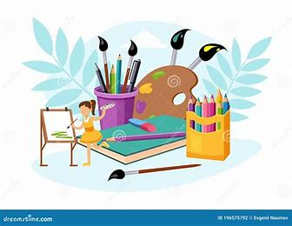 | French- Shopping in France  - To build numbers and prices confidently in French.  - To name different foods in French and notice patterns in sounds.  - To be able to join in with and perform a short, repetitive story using voice and actions to communicate to an audience.  - To be able to use vocabulary to describe a quantity of different food nouns.  - To be able to explore and understand an authentic French text.  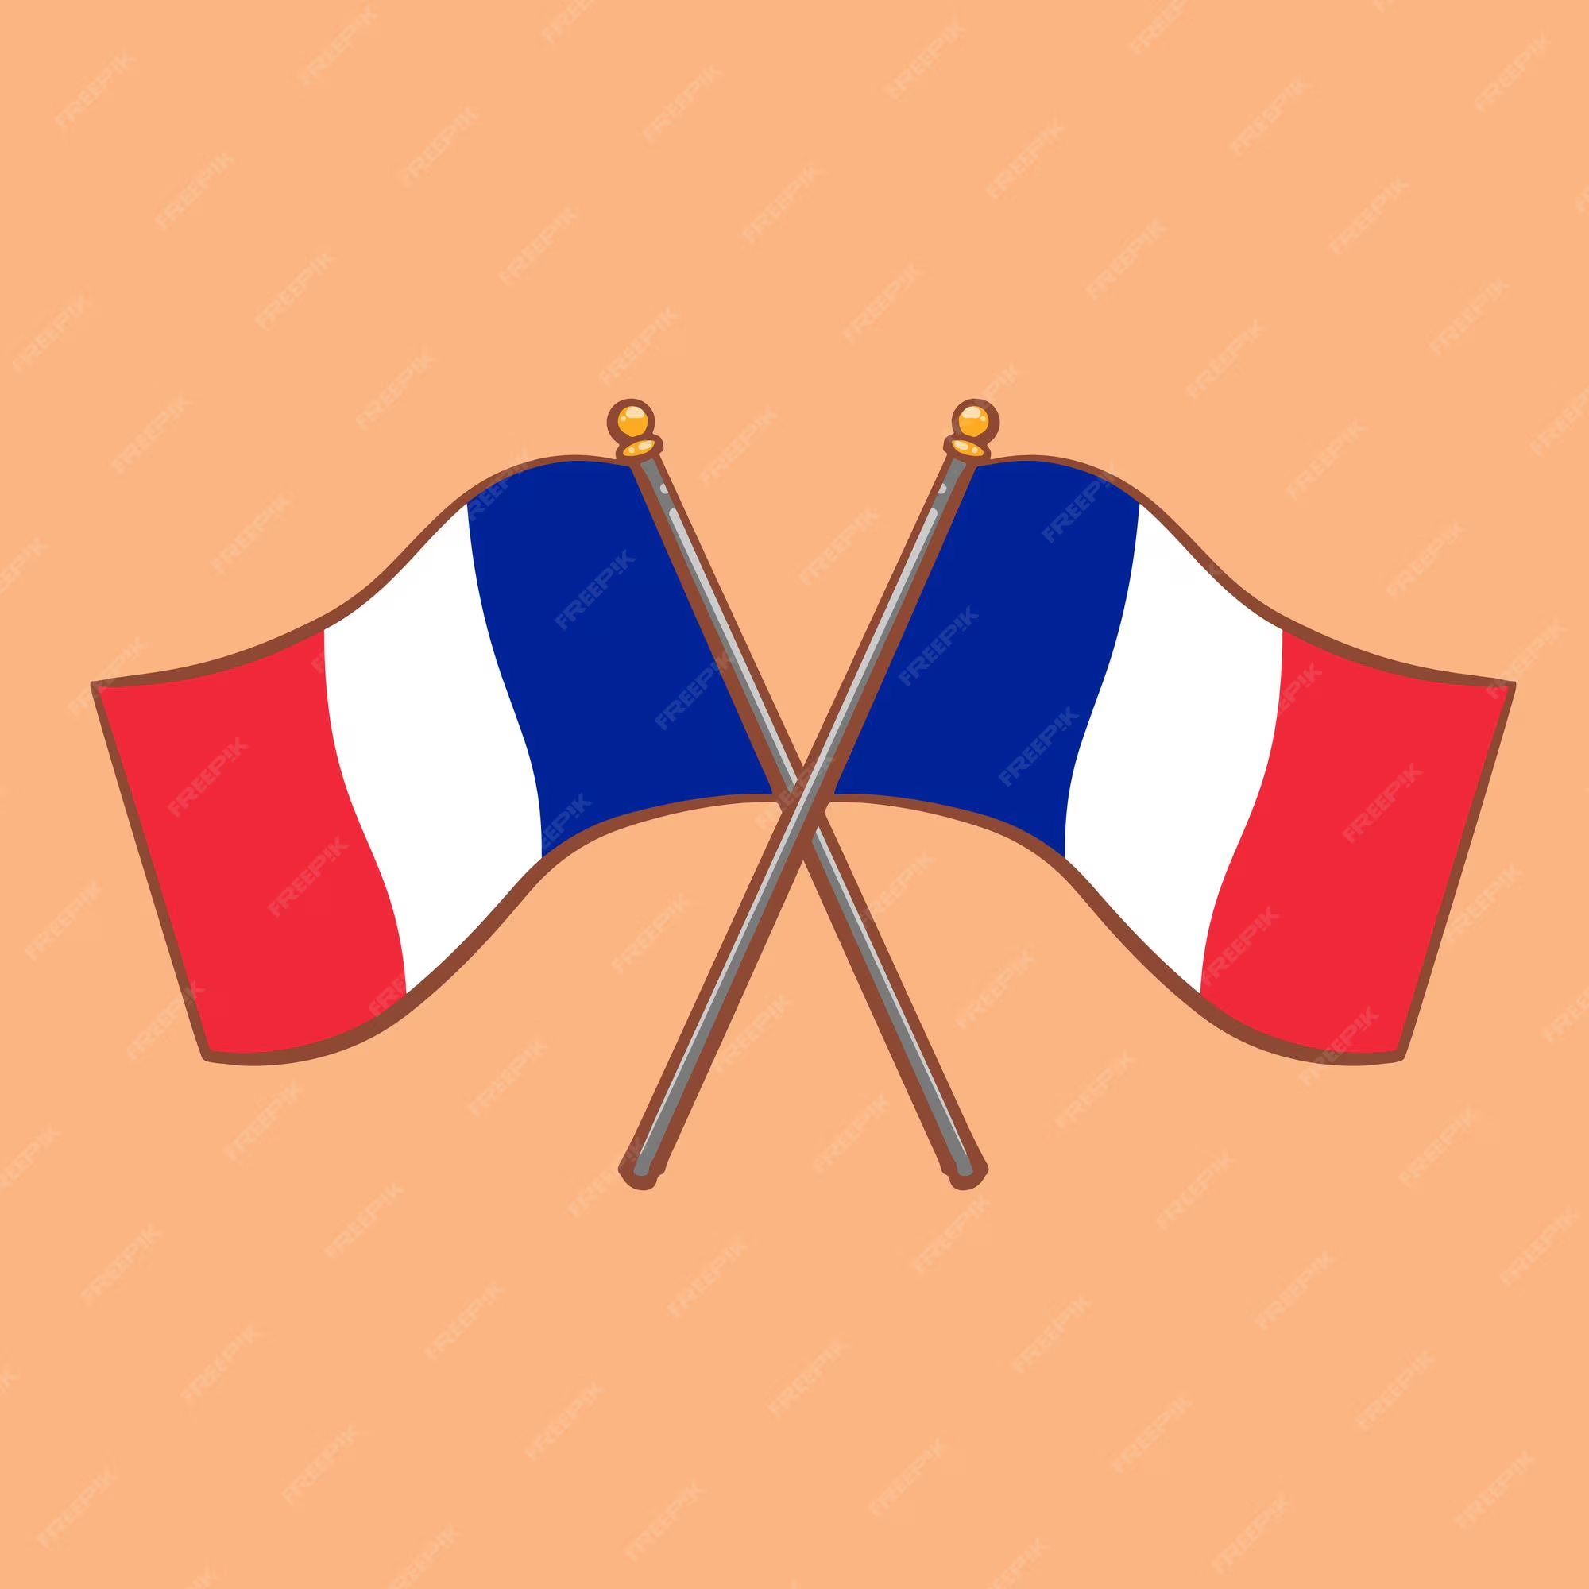
Computing- Using Microbits  - To tinker with a new piece of software.  - To program an animation.  - To recognise coding structures. To create a program for a specific task.  - To create a program.   | RE- Why is the bible the best selling book of all time?  - Identify events involved in the compilation and creation of the first Christian Bible.  - Comparing different types of writing found in the Bible and discussing their purposes.  - Explain the criteria used to decide which texts were included in the canonised Bible.  - Explain the impact of key figures and events on the development of the modern-day Christian Bible.  - Describe how and why the Christian Bible has developed over time.  - Investigate and identify where the Bible is found in different churches and how this has changed over time.  - Identify examples of how the Bible has influenced modern British life.  - Present their learning about the Bible’s impact and relevance. | Music- Adapting and transposing motifs  - Learn a new song, singing in time and in tune while following the lyrics.  - Identify motifs aurally and play a repeated pattern on a tuned instrument.  - Create and performing a motif, notating it with reasonable accuracy.  - Transpose their motif, using sharp or flat notes where necessary and change the rhythm.  - Combine different versions of a musical motif and perform as a group using musical notation.

