I
We hope you had a lovely half term and spent some quality time together and had a chance to recharge your batteries. Last half term was full of fun and adventures, and there’s lots more planned this half term.
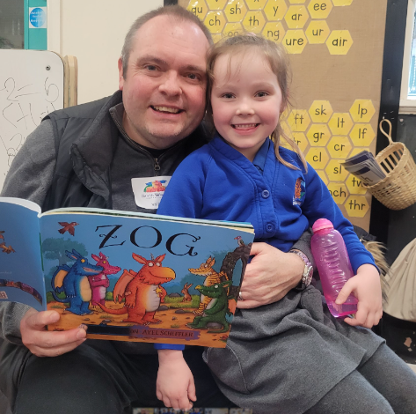
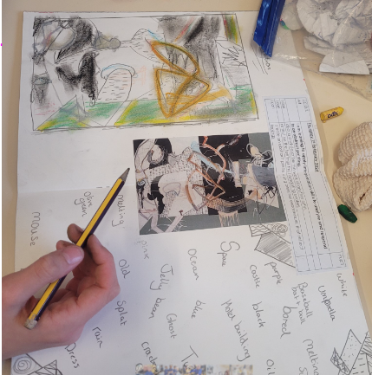

PE
This half term all children will continue to have their weekly PE lesson on Tuesday along with Martial Arts on a Wednesday. Please can you ensure that your child comes in their PE kit on both days. The school PE kit comprises of black/blue shorts with a plain white, black or blue tshirt.

World Book Day is annual event where children come together to celebrate books. This year children are asked to come to school dressed in their PJs ready for their bedtime story.

March
5th Year 4 David Nieper music concert.
7th World Book Day
13th March Year 6 visit to Maple Mews
18th March HSBC Financial Education Workshops
19th & 20th Parents Evening
21st March Year 2 and Year 6 Fire Safety Talk
28th School closes for Easter
diary dates

Parent Code of Conduct
At South Wingfield Primary School we are very fortunate to have a supportive and friendly parent body. Our parents recognise that educating children is a process that involves partnership between parents, class teachers and the school community.
We believe staff, parents and children are entitled to a safe and protective environment in which to work. Behaviour that will cause harassment, alarm or distress to users of the premises is contrary to the aims of the school.
We expect parents, carers and visitors to:
- Respect the caring ethos of our school
- Understand that both teachers and parents need to work together for the benefit of their children
- Demonstrate that all members of the school community should be treated with respect and therefore set a good example in their own speech and behaviour
- Work with the school to reconcile a child’s perception of events with other points of view in order to bring about a peaceful solution to any issue
- Approach the school for help to resolve any issues of concern
As per our complaints policy if you have a concern please arrange to see the class teacher, this can be done by phoning the school office. If you choose to email a member of staff please note that they will not respond out of school hours and will endeavour to get back to you at the earliest convenience.
Attendance
My child is unwell, should I send them to school? Sometimes it is difficult to know whether to keep your child off school or send them in. Always try and send your child to school if they are a little ‘under the weather’, for example, with a runny nose, headache, tummy-ache. The school will always contact you if your child is unwell, which is why it is vitally important that we have your correct contact details. hours from the last bout of illness. This is to ensure that any infection does not spread through the school.
HOWEVER, please do not send your child to school if they have any infectious illnesses like Chicken Pox, Measles etc. Medical confirmation from your doctor will ensure your child’s absence is authorised. If your child has been vomiting or is suffering from diarrhoea, then they must stay away from school for 48 hours.
The NHS has a handy guide to the most common childhood illnesses and what you should do. Please do contact the school office if you need any additional advice or support and we will be happy to help. https://www.nhs.uk/live-well/is-my-child-too-ill-for-school/
In line with the school’s attendance policy we request confirmation of all medical appointments, this can include a confirmation text. Please email to mkealy@southwingfield.derbsyhire.sch.uk or show the school office.
A polite reminder that we are not able to administer medicine, and therefore we kindly ask for parents to do so during the school day.
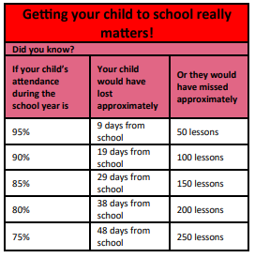

Holidays During School Time
The Department for Education expects schools and local authorities to promote good attendance and reduce absences, including persistent absence. This is because we know that missing out on lessons leaves children/young people vulnerable to falling behind. Children with poor attendance tend to achieve less in both primary and secondary schools.
Amendments to the Education (Pupil Registration) (England) Regulations 2006 which came into force on 1st September 2013 made it clear that Headteachers should not grant approval for any leave of absence during term-time, including holidays, unless there are exceptional circumstances. Our Attendance Policy and national guidance clearly states that holidays should be taken within school holidays and parents should avoid seeking to take children out of school during term time.
Head Teachers may not grant any leave of absence for holidays during the term time unless there are exceptional circumstances; in these cases it is the Head Teacher who determines the number of days a child can be away from school if the leave is granted.

For the school to comply with the law, we are unable to approve requests for leave of absence for reasons that are not considered to be special or exceptional.
Some examples of any exceptional circumstances where leave may be granted during term time are as follows:
- If a parent is service personnel and is returning from a tour of duty abroad where it is evidenced the individual will not be in receipt of any leave in the near future that coincides with school holidays.
- Where an absence from school is recommended by a health professional as part of a parent or child’s rehabilitation from a medical or emotional issue.
- The death or terminal illness of a close relative, only if Headteacher is satisfied that the circumstances are truly exceptional.
- Out of school programmes such as music, arts or sport operating at a high standard of achievement. Documentary evidence of this event will be required.
- Religious observance – The Education Act 1996 S444(3) (c), states ‘’on any day exclusively set apart for religious observance by the religious body to which his/her parent belongs’’.
- To attend a wedding or funeral of a close relative if the Headteacher is satisfied that the circumstances are truly exceptional. Leave should only be authorised for this purpose when a Headteacher is satisfied that there is a persuasive reason for holding the wedding during term time and there is an onus on parents to show clear evidence that this absence is absolutely an exceptional circumstance. In difficult family situations the Headteacher may use his/her discretion in granting leave and each case should be addressed on its individual merits, taking into account the overall welfare of the child.
Where there are exceptional and unforeseen circumstances that fall outside of the above, the Headteacher agrees to consult with the governing body prior to any authorisation being given to the parent. Evidence would be required in each case.
Parents needing leave of absence for exceptional circumstances should complete a form at least two weeks before the anticipated start date. The reason for the request should be given in detail. Applications should be made before the leave is arranged as absences will not be granted retrospectively. The forms can be collected from the school office.
This is Government policy which schools are legally required to uphold. Parents who take their Parents who take their children on holiday without permission will incur unauthorised absences for their child. Parents could be issued with a fixed penalty notice and/or court action which is actioned by Derbyshire County Council, not school.

