South Wingfield History Policy
This policy reflects the values and philosophy of South Wingfield Primary School in relation to the teaching and learning of history. Our vision is to deliver a rich and relevant curriculum, in which the children can fully engage and develop a love of learning which will remain with them for life. History is a foundation subject in the National Curriculum. It gives us a sense of identity, set within our social, political, cultural and economic relationships. It fires the children’s curiosity about the past in Britain and the wider world. History plays an essential part in preparing us for living and working in the contemporary world. While history is about real people who lived in the past, its fundamental concern is the understanding of human conditions, set in the context of time. In history, children find evidence, consider it and reach their own conclusions. To do this, they need to research, sift through evidence and argue their point of view, all essential skills. By our concepts and milestones to underpin our history curriculum we will ensure that there is full coverage of the National Curriculum. We consider the children’s interests, as well as the context of the local area and current events.
Our long term plans and unit planners ensure that the children receive a balanced history curriculum across school and our progression of skills and vocabulary documents show a wide coverage of the national curriculum across the relevant key stages. We teach history through understanding the world in Early years and work to the objectives set out in the Early Years Learning Goals which underpin the curriculum planning for children aged three to five.
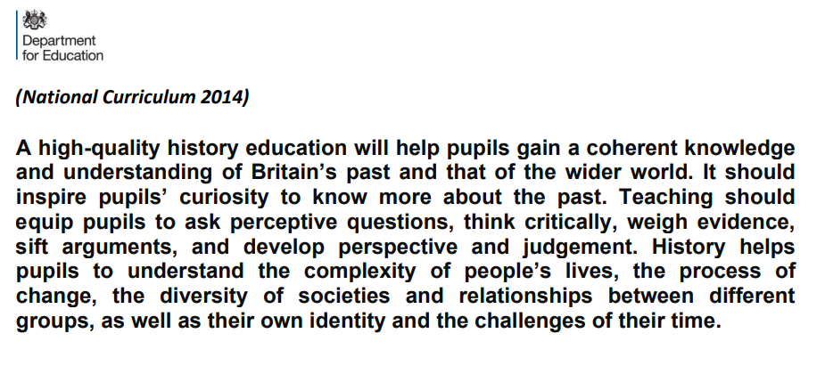

The aims of History in our school are:

  - To help the children to develop a sense of identity and to make sense of the world in which they live
  - To promote a positive attitude towards history to promote an interest and enjoyment in learning about the past and the world they live in
  - To fulfil the requirements of National Curriculum for history
  - To provide a history curriculum which is exciting, fun, broad, balanced, relevant and ambitious.
  - To ensure the progressive development of concepts, knowledge and enquiry skills – transferable to all areas of learning and of life
  - To organise the teaching of history into levels of increasing challenge, to ensure the development of key skills, a breadth of knowledge and familiarity with key vocabulary.
  - To develop the skills of enquiry, investigation, analysis, evaluation and problem solving.
  - To address issues of equal opportunities in context, challenging stereotypes, with an awareness of the background and cultural heritage of all pupils
  - To support or provide a means of enriching other areas of the curriculum.

In the teaching and learning of History we can identify a number of objectives for the children:
  - To develop a sense of chronology and an understanding of how to use of historic terms
  - To build up knowledge of events and people from the past
  - To enable children to ask and answer questions about the past and their world
  - To learn about the development of Britain, Europe and the wider world
  - To develop research and interpretation skills using a range of media and artefacts
  - To develop an awareness of the nature and use of evidence
  - To enable children to communicate their knowledge and understanding in a variety of ways
  - To respect the thoughts, beliefs, motives and actions of people in the past
  - To develop and use correctly historical language and a vocabulary of historical terms
  - To encourage children to ask historical questions, for example why did this happen? How do we know this is true?

Progression & Continuity
To bring history to life we aim to make learning exciting and interesting and relevant. We start from what the children know and move forward from that point. Planning for history is set out in termly topics undertaken over a two-year rolling programme. These topics are also set out on our long-term plan to ensure that there is no unnecessary duplication or omission and that there is a development of concepts, skills and attitudes across each year group. In order to achieve the subject’s aims and objectives, the teaching of historical concepts, skills and attitudes are integrated across the curriculum.
In KS1 the teaching of history begins with what pupils know: the history of their own family, including before they were born, concepts of events that happened in the past – how do we know: talking to parents, grandparents about their childhood. KS1 prepares pupils for the topics they will cover in KS2 and develop a curiosity of the past and ability to make connections and links about change. Throughout school each topic will revisit key concepts over the key stage being taught so that there is a progression of skills as well as a depth of subject knowledge. These concepts can be found on our progression of skills document. Also, prior knowledge and understanding of vocabulary and terminology enables the children to develop their skills of enquiry and questioning, to use different sources and look at the different interpretations of the past and of points of view from a young age. Wherever possible teachers plan to enhance topics through trips, theme days, visitors to school and the use of artefacts to make the curriculum more real. As well as taking its own part in the school curriculum, history contributes to the wider aims of Primary Education. Reading and writing skills are essential for undertaking historical enquiry, for collecting information and source material, making notes and following instructions.
Evaluating historical evidence requires children to articulate their ideas, and to compare and contrast their views with those of other people. The study of time and chronology and analysing data and the use of timelines and charts contributes to the children’s mathematical understanding. Each class has a time line which previous learning is added to so that children can understand their learning in more of a chronological context.

Chronology
The history topics do not have to be taught chronologically but children have to have chronological awareness of where their period fits into. The use of class or school timelines helps support their understanding of the connections between local, regional, national and international history and economic, social, cultural, religious history and the different timescales.
Special Educational Needs
Special Educational Needs support within our History forms part of the broad and balanced education that all children are entitled to. Teaching and learning must appeal to a range of learning styles It should take account of the different needs of the children and address the specific needs of target groups within a cohort. Ideally learning will take place in a range of settings. It should promote opportunities to practise speaking and listening skills and use key vocabulary. Where possible links should be made to people and places familiar to learners to help inspire and engage them. Activities should reinforce children's understanding of the subject. For children with special educational needs, tasks can be broken down into small steps, giving children achievable goals. The more able children should be given open-ended tasks and opportunities for further research and more challenging study in order to develop their knowledge, skills and understanding in the field of historical enquiry. Opportunities to work in structured and planned groups of mixed ability develops greater interaction, speaking and listening skills and cooperation between children.
Equal Opportunities
All planning must take account of equal opportunities and not support negative stereotyping, in any form. All staff at South Wingfield Primary School are responsible for ensuring that all pupils, irrespective of gender, ability, ethnicity and social circumstances, are given an equal opportunity to enjoy and achieve in history. Lessons should be inclusive and involve a variety of approaches that encompass the children’s preferred learning styles. History provides so many opportunities for reinforcing this ideal and can engender a healthy respect for the similarities and differences of the cultures and societies.

Assessment
The purpose of assessment in History is to support children’s progress and to make judgements about standards of children’s work in history in the longer term. Through monitoring children’s progress both during and at the end of a topic, teachers can evaluate the impact of the curriculum and show what progress looks like and how the children have retained what has been taught. The glossary grid will provide class teachers with further evidence in assessing the children’s knowledge and skills. Teachers use the online assessment grid which refers to the national curriculum statements to monitor whether a child is working below, working at, or working above. Pre and post block assessments are also completed each half term to show the knowledge that the children have gained and retrieval starters are used to allow children to constantly revisit previous learning and recap that sticky knowledge. Feedback should enable the children to focus on the next steps in their learning and the means of doing it. Assessment tends to be formative and gathered in the following ways: Self-assessment, Regular marking and checking of work in accordance with the marking policy, Whole class, group, or one-to-one discussions, Observation, Formal/informal meetings of staff involved in the teaching of History, External inspection and advice.
Resources
Resources will be kept in the organised resources room, which has been labelled and split into topics to allow staff to gather all artefacts and resources needed for their current topic. Staff also use the Internet where up to date resources can be used from educational sites, the educational sections of museum web pages as well as news clips, photographs, images, film clips and maps, for example. We are currently reviewing the resources available and the need for updating and replacing current resources to match our new curriculum topics.
The role of the coordinator is to:
- Provide advice and guidance to colleagues
- Keep staff appraised of significant developments within the subject
- Monitor progress towards the agreed aims and advise the Headteacher on action needed
- Maintain, develop and improve resources
- Ensure progression of skills and vocabulary across school
- Keep up to date with History-related issues
- Develop links with other schools in order to share best practice
- Attend relevant courses and address the training needs of others.

