Literacy
Phonics- We will consolidate our Phase 3 learning revising the digraphs and trigraphs we have learnt as well as continuing to learn the rest of our tricky words. We will then work on segmenting and blending longer, polysyllabic words and ccvc/cvcc words.
Writing- We will continue to look at writing for a purpose and the children will write their own lists, captions and sentences. We will focus lots this half term on beginning to write independently. We will continue to learn about the language used in story writing and apply these to our own stories. Many spellings will be phonetically plausible and this is fine at this stage. We would encourage the children to spell the tricky words we have been reading correctly.
Reading- We will have a focus book each week linked to our theme. We will continue to look at features of a book such as the title and author as well as rhyming words and sequencing we will also be thinking about predictions and retelling a story this half term. Some key texts will be: Little Red Riding Hood, Zog and the Flying Doctor and Oliver’s Vegetables.

Significant Women
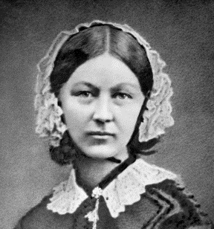

Physical Development
In PE we will be playing net/wall games and developing our skills in this area.

PSED
This half term we will think about different changes. We will explore how people’s needs change as we grow from young to old, talk about how we might change at school and prepare for the next year group. We will talk about how changes might happen such as getting a brother or sister and think about how changes can make us feel and what we can do about these feelings.
Maths
Number:
We will continue to work on our number bonds to 10 and work towards being able to fluently recall these number bonds. We will also be looking at our addition and subtraction within 10 and using practical resources to help us with this. We will be talking about odd and even numbers and how we can double, half and share shapes and quantities.
Shape, Space and Measure
We will consolidate our learning and understanding of patterns and relationships as well as thinking about special awareness and map work.

Communication and Language We will establish good routines for speaking and listening within the classroom and model correct grammar and new vocabulary. We will have a word of the week and display new vocabulary linked to our topic. The children will have a daily ECaT session where they can share and discuss work completed at home. We will use BSL to support communication each day in the classroom. We also learn a weekly poem and perform this as a class.

Understanding of the World
This half term we will be thinking all about the women who changed Britain and focusing our learning on the wonderful Florence Nightingale. We will think about how she changed hospitals and medicine. We will have visits from modern nurses and think about the different types of nurses we have. We will also continue our learning on Plants and we will be planting in our outdoor area, completing observations of plants growing.
Expressive Arts and Design
This half term we will have a Art focus. Children will focus on developing their ability to tell a story through drawing. Our lessons will include creating textures, observational drawing, character expression and storytelling through illustrations.

Music- Children will learn how to make high and low sounds with their voices and instruments.
RE
Our topic is ‘Why should we care for the world?’. Children will explore their own beliefs about who owns the world and recognise the belief that humans were created last for a reason. They will explore different religions worldwide view on looking after the world and think about how they can help contribute to looking after the world.

