South Wingfield Spring 2
KS1 Homework Tasks
Daily task:
Reading, reading and more reading.
You should aim to read 5 times a week to a grown up.
Weekly tasks:
Practise your spellings (refer to the attached document for creative ways to learn them).
Complete the weekly Spelling Shed task.
Year 1s-Practise your number bonds to ten. Play on your N7mbots account. Year 2s- Learn to recite your times tables, individual tables have been selected for you on TT Rockstars.
Topic homework options- Choose at least two to complete by the end of the half term.
Science | Creative |  | English | Geography
Create your own  fact file about  an animal that lives on the African  savannah.  OR  Have a go at growing some plants. You could send us photographs or draw them. You could write some instructions on how to plant it or how to care for your plant. | 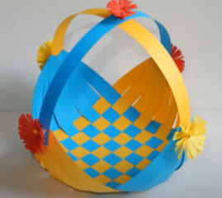  Make your own woven baskets. Here is a tutorial you could follow.  OR  Make your own animal puppet of an animal that you might find on the African savannah.  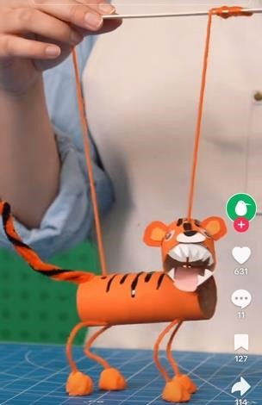 | Make you own African crown.  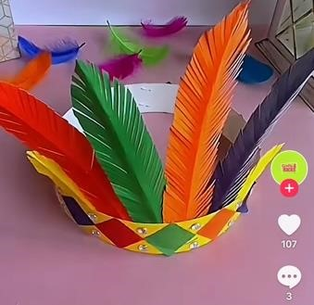  Or  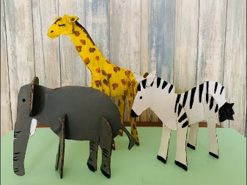  Make your own African animal using cardboard.  Create your own  sculpture of the world on a balloon making  sure to add all 7  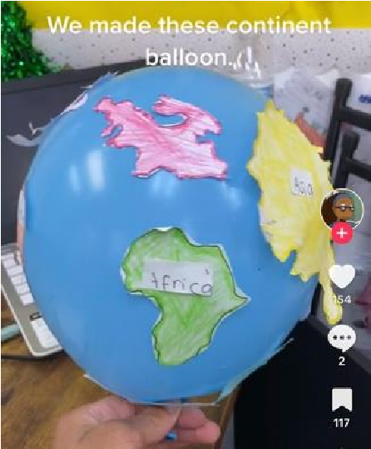  continents. | Write a description using powerful adjectives of a type of landscape you might find in Kenya.  OR  Make your own short story about an animal that lives in Kenya (Make sure to include drawings).  OR  Listen to our text for this half term here. Write a short story of what might happen in Lila’s village now it has rained. | Make your own  African flag. Be creative about the materials you use.  OR  Research some key facts about a country which borders Kenya. Are the countries similar or different?

