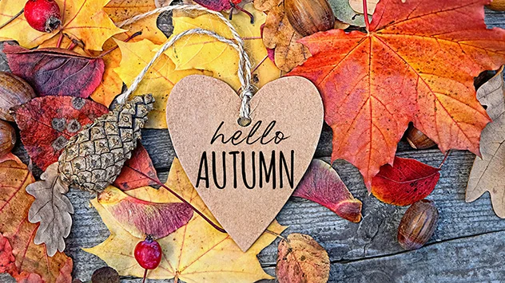 Class 3 Newsletter – Summer
We hope you all have a wonderful break over the Easter Period.

Our topic for Summer 1 is The Tudors

This term the children will be learning all about the Tudors. We will start with the Tudor family Tree and we will include lessons on fashion, food, childhood, crime and punishment and much more. This is such an exciting topic and we think the children will find it most interesting. The Tudors homework grid has been attached to Dojo, we look forward to seeing what they produce.

Logins and passwords – information from the start of the year

We have given your child a folder which SHOULD BE KEPT IN A SAFE PLACE AT HOME PLEASE. It will contain their spellings for the year. In future, termly spellings will also be posted on the website for you to refer to if you wish. You should also have received;

- Logins and passwords for TT Rockstars, Charanga, Sumdog and Spelling Shed, learning platforms.
- Lists of Statutory Spellings (words children should know how to spell independently by the end of this year).
- Spelling, grammar and punctuation terms. (Word classes and definitions that children should learn for spelling, grammar and punctuation).
Please add these to the folder you have been given for future reference and safe keeping. PLEASE KEEP THE FOLDER AT HOME.

Keeping you informed

At the beginning of each term we will post on the School website termly information, including spellings, knowledge organisers and key events. These will include everything that you and your child will need to know ready for the upcoming term. This is to save on paper, so please do keep checking the website for recent school newsletters and information too.

Trips and events this Term

This term we have two trips coming up. One will be on June 11th to Sheffield Manor Lodge.
One will be on June 19th to The Halle, to play our violins with lots of other children who have taken part in the Music Partnership Lessons.
The children will also be performing with their violins at school to parents on May 16th

THERE WILL BE MORE INFORMATION TO FOLLOW ON ALL OF THESE EVENTS SO PLEASE DO NOT WORRY.

PE in Class 3

This term our PE sessions are on a Tuesday with Mr Woodhouse and swimming on a Wednesday. Please send children with swimming things on a Wedneday, a list of what is needed has been sent out to you. Lunch will be 15 minutes early on a Tuesday and Wednesday to accommodate PE so please ensure your child has plenty if they are sandwiches.

Reading expectation in school and at home

In school your child will be part of daily guided reading groups and will also read individually to an adult at school. They will be expected to read ideally 5 times each week at home too. It does not always have to be their reading book, it may be a book of their own choice, a comic or even a newspaper. It would be helpful if reading at home was recorded in their reading record and signed by an adult each time, we need this in order to change children’s books appropriately. Please fill in one box in the reading record book for each day your child reads.

Your child has been given a reading record and a reading packet that they can use to keep their reading record and reading books in. They will need to bring this into school daily and place in their tray.

Homework in Class 3

There is an expectation that your child regularly logs onto TT Rockstars, Sumdog and Spelling Shed at home to complete tasks we have set for them. We will be monitoring how often your child logs onto these online platforms, so that we may identify any areas/difficulties that may need further addressing, e.g. a particular times table or spelling pattern.

Please encourage your child to learn their times tables off by heart at home to support learning in school. We will be learning times tables daily and reciting them as well as completing weekly times tables tests on Fridays.

Alongside online homework, we would like your child to complete 2 pieces of homework each term relating to the topic that we are learning in class. Our topic for Summer is The Tudors . We have attached a homework grid on Class Dojo for your child to choose 2 tasks from. Children’s homework may take any form. It could be a PowerPoint presentation, a piece of writing, a combination of typed up research and hand-drawn pictures, a comic strip or they might like to do some artwork or produce a model, write a story, song, or poem. Children can complete their piece of topic homework at any point during Summer term and they are more than welcome to bring it into school to show the rest of the class and, if possible, have it added to our topic display. However, if you would prefer to email your child’s topic homework to school then that is absolutely fine too! We can then print a picture of it out for display.

Musical instruments

Please ensure your child brings their violin to school every Thursday ready for the lesson on a Friday.

Other useful information

- If possible, could all uniform and water bottles please be clearly labelled! Children will keep their jumpers on their pegs if they take them off and their water bottles will stay on their desks throughout the day. However, making sure everything is labelled ensures good hygiene is followed and ensures there are no mix ups at home time!

- No toys are allowed in school, including trading cards. Fidgets are allowed related to the childrens’ needs.

- Mrs Wilmot will teach the children every other Thursday afternoon to cover for Mrs Wood’s PPA

- Every Friday your child will have a weekly spelling test of usually ten words. We will ask your child to write their weekly spelling score in their reading record.

- Your child will have a times table test each Friday. This term will be mainly concentrating on the 2,3,4,6, and 8 times table.
- Your child has all the stationery they require in school. Please do not send in pencil cases or stationery.

SNACKS

A snack at break time is nice to have. Your child should bring in healthy snacks into school, PLEASE….NO NUTS. Some examples for snacks;
- Whole or sliced fruit.
- Vegetable sticks, e.g. celery, carrot, pepper, cucumber. ...
- Bag of plain popcorn.
- Bread sticks.
- Rice or corn cakes

If you have any questions or concerns, please do not hesitate to contact us – preferably at the end of the school day – when we will have a little more time and be more than happy to discuss anything.

Mrs Williams & Mrs Wood

