Tudors Homework Grid
Have a go at drawing Henry VIII – can you make him as realistic as possible?  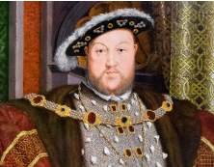 | Design your own Tudor town and include:  - Tudor houses  - A Tudor farm  - Farm animals  - Stocks  - A church 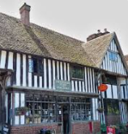 | Write an acrostic poem using the letters:  T  U  D  O  R  S | Create a fact page about the Tudors. Try to include some amazing facts that may surprise people  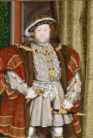
Make a 3D model of a Tudor house  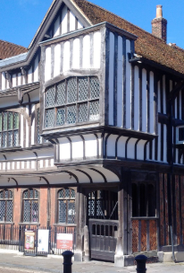 | Write a short diary entry of ‘a day in the life of a Tudor’ Try to include historic facts.  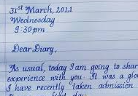 | Make up little song/rhyme with a friend about the Tudors.   | Find out about an important historical event during the Tudor times and write an information page about it.  Can you find something that people may not know about already?
Create a fact file or poster about a famous person during Tudor times.  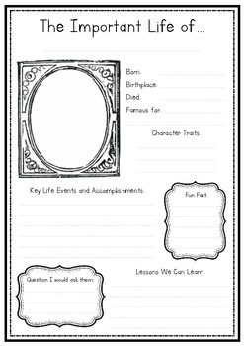 | Compare modern life with the life of a child in Tudor times.  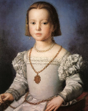 | Crime and Punishment – find out about the gruesome punishments the Tudors liked to carry out and how public they were…  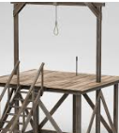 | Queen Elizabeth 1st – find out all about her and why she was famous. Create a character profile for her.  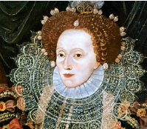
Choose a homework tasks to complete for Spring Term
This homework Grid lasts until May half term.

