Greece Homework Grid
Create a tourist leaflet on a place of your choice in Greece.  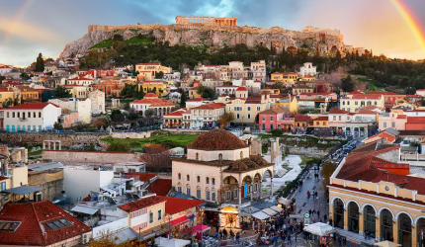 | Design your own holiday town and include:  - A beach  - A restaurant  - Hotel  - A shop  - A tourist attraction | Write an acrostic poem using the letters:  G  R  E  E  C  E | Create a fact page about the Greece  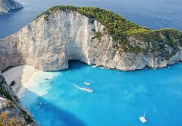
Make a 3D model of a Greek island  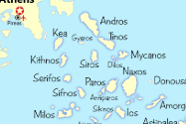 | Write a short adventure story about a holiday.   | Make up little song/rhyme with a friend about Greece.   | Find out about an important historical event in Greece and write an information page on it.  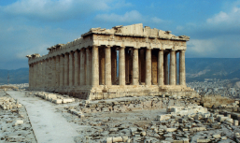
Create a fact file or poster about a famous person from Greece  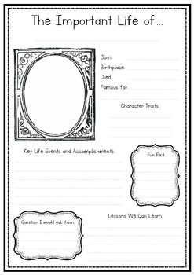 | Compare the UK with Greece  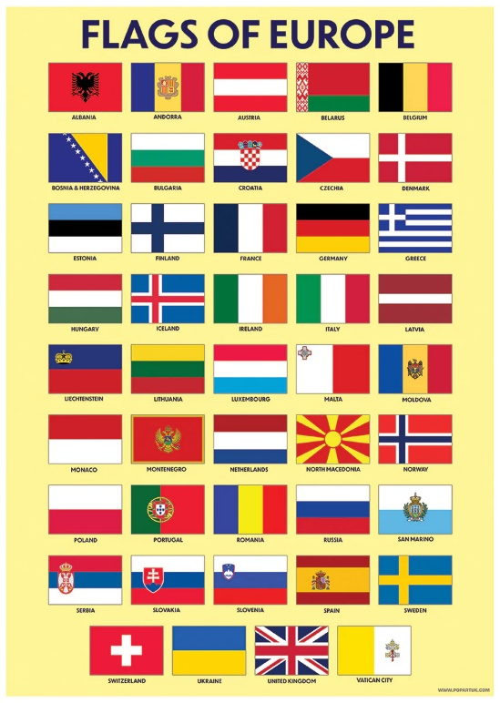 | Re-design the Greek flag   | Write a diary entry if you have ever been on holiday to Greece and give details of what you did
Choose a homework tasks to complete for Spring Term
This homework Grid lasts until Easter.

