SPAG/English  SPAG- Children will be learning a range of techniques that link to our style of writing. They will also be learning their spelling rule for the week and completing work based around this.  English- In English this half term children will be writing a travel brochure all about Mexico, they will also be writing their own narrative set in Mexico.  Reading- Our topic book this half term is Mexikid  Our reading for pleasure book this half term is The Colours of History  Our poetry book this half term is I’m the seed that grew the tree  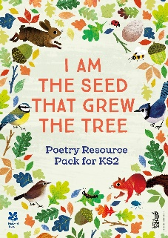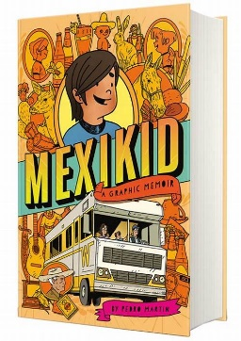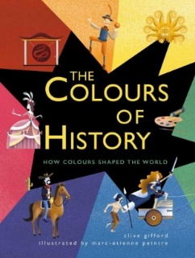 |  | Geography- Mexico Today  - Compare and contrast Mexico and the United Kingdom  - Where in the world is Mexico?  - Weather and climate in Mexico  - Physical geography of Mexico  - Human geography of Mexico  - Mexican culture  - Mexico as a tourist destination  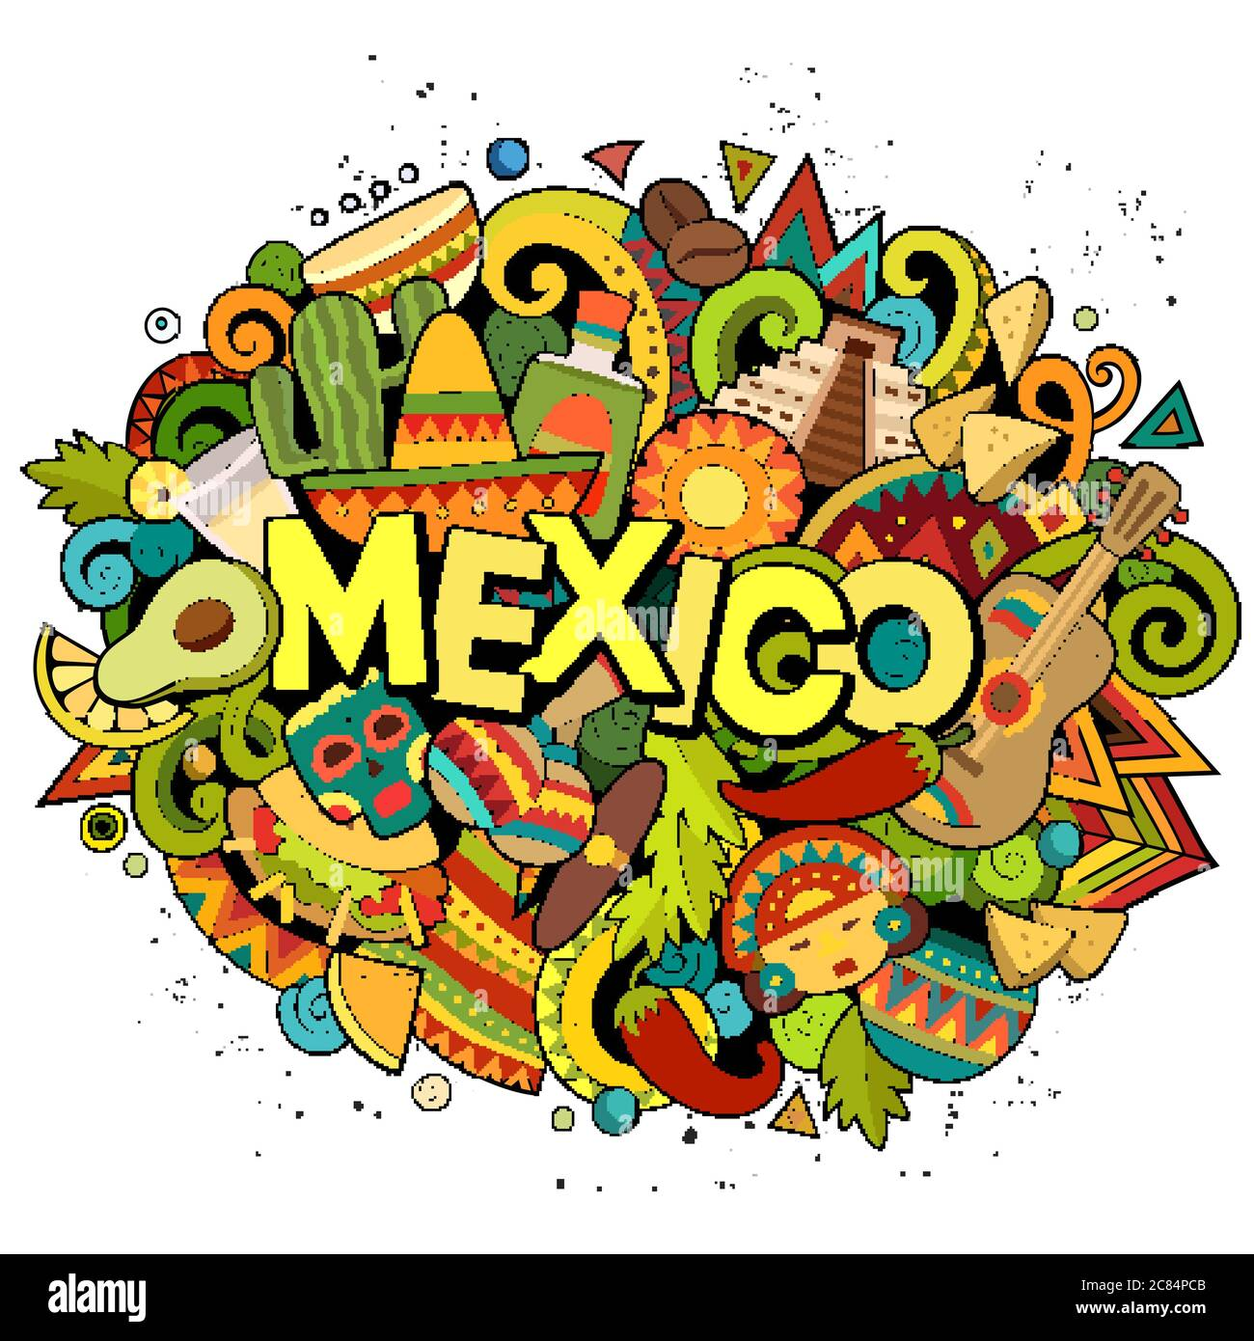
Maths  Children will be continuing their topic all about decimals and percentages, they will be looking at representing a variety of numbers, figuring out percentages, rounding decimals and also adding and subtracting decimals.  The children will then move onto looking at shape, coordinates, money and measurement.  Times Table of the Term (Children’s TT Rockstar’s test on a Friday will be based on this times table) Both year groups will be doing mixed times tables up to 12x.  Year 4 children will also take place in the Multiplication check. This will take place in the second week of term. More information about this can be found on our class dojo page. | Science Y4 (Taught by Miss Wareham)  The Digestive System  - Step 1 Teeth - carnivores, herbivores and omnivores  - Step 2 Human teeth  - Step 3 Layers of the teeth  - Step 4 Plan - tooth decay experiment  - Step 5 The digestive system  - Step 6 The digestive system - model  - Step 7 Findings - tooth decay experiment  Food Chains  - Step 1 What is a food chain?  - Step 2 Interpret food chains  - Step 3 Draw food chains  - Step 4 What would happen if?  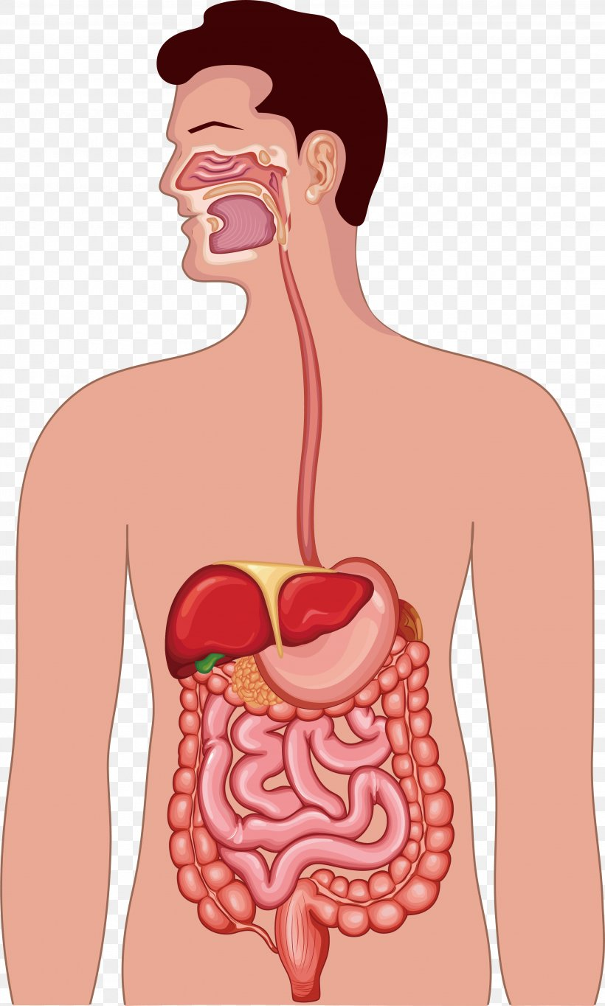 | PSHE- Growing up  - Understanding that everyday hygiene routines can limit the spread of infection.  - Identifying what contributes to who we are.  - Recognising their individuality and personal qualities.  - Identifying personal strengths, skills, achievements and interests.  - Identifying the physical and emotional changes that happen when approaching/during puberty.  - Identifying the importance of keeping clean and how to maintain personal hygiene.  - Understanding the human life cycle.  - Understanding privacy and personal boundaries.  - Recognising what seeking and giving permission (consent) means.  - Explaining where to get advice or report concerns if worried.  - Learning about stereotypes.
PE  Children will be having a weekly PE session with AVSP on a Tuesday. Children will be having their second PE session on a Thursday this term. Our focus for PE this term is cricket.  PE kit needs to be worn on a Tuesday and Thursday please. We have a PE uniform policy that needs to be followed, please see the newsletter for more information. | DT- Digital Word- Monitoring Devices  - Describe what is meant by monitoring devices and provide an example.  - Explain briefly the development of thermometers from thermoscopes to digital thermometers.  - Research a chosen animal’s key information to develop a list of design criteria for an animal monitoring device.  - Write a program that monitors the ambient temperature and alerts someone when the temperature moves from a specified range.  - Identify errors (bugs) in the code and ways to fix (debug) them.  - State one or two facts about the history and development of plastic, including how it is now affecting planet Earth.  - Build a variety of brick models to invent Micro:bit case, housing and stand ideas, evaluating the success of their favourite model.  - Explain key pros and cons of virtual modelling vs physical modelling.  - Recall and describe the name and use of key tools used in Tinkercad (CAD) software. | French- Space Exploration in France  - The solar system in French  - French sun and moon metaphors  - Comparing planets in French  - A galaxy guide in French  - French alien world  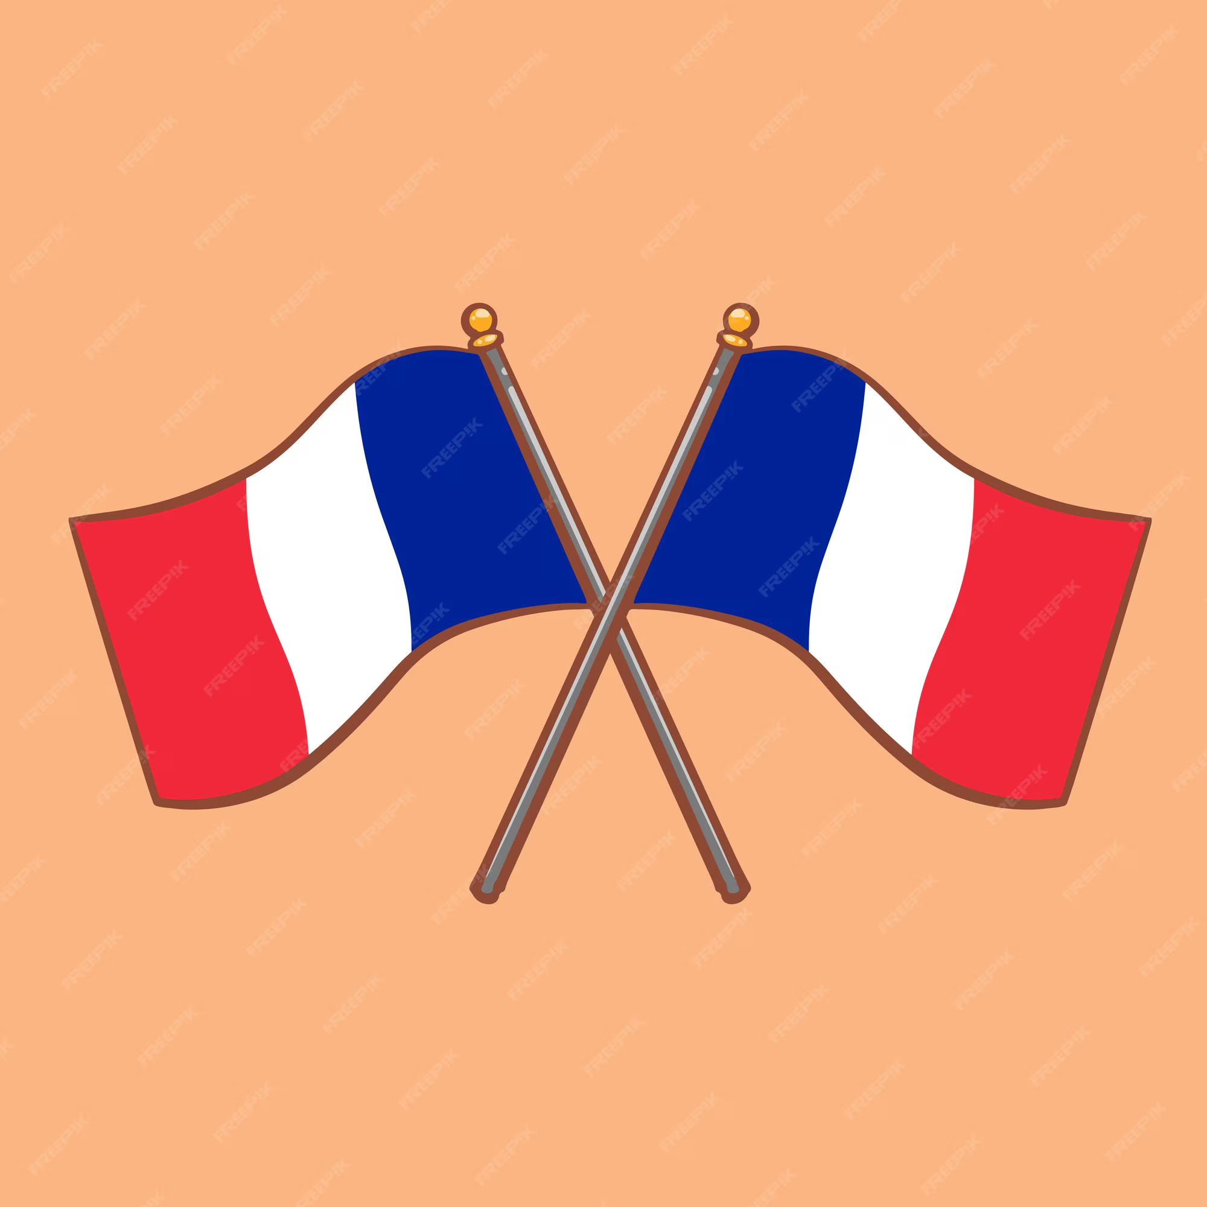
RSE-
Y4- Puberty
Y5- Puberty (including periods)

We will be following the Kapow Unit of learning and children will be looking at age appropriate content for their year group. If you require any more information on this please send me an email. A text message will be sent out before RSE begins to be taught.

Computing- Search Engines  - Explain what a search engine is, suggest several search engines to use and explain how to use them to find websites and information.  - Suggest that things online are not always true and recognise what to check for.  - Explain why keywords are important and what TASK stands for, using these strategies to search effectively.  - Recognise the terms ‘copyright’ and ‘fair use’ and combine text and images in a poster.  - Make parallels between book searching and internet searching, explaining the role of web crawlers and recognising that results are rated to decide rank. | RE- Why is the bible the best selling book of all time?  - Identify events involved in the compilation and creation of the first Christian Bible.  - Comparing different types of writing found in the Bible and discussing their purposes.  - Explain the criteria used to decide which texts were included in the canonised Bible.  - Explain the impact of key figures and events on the development of the modern-day Christian Bible.  - Describe how and why the Christian Bible has developed over time.  - Investigate and identify where the Bible is found in different churches and how this has changed over time.  - Identify examples of how the Bible has influenced modern British life.  - Present their learning about the Bible’s impact and relevance. | Music- Ballard’s  - Identify the key features of a ballad.  - Perform a ballad using actions.  - Sing in time and in tune with a song and incorporate actions.  - Retell a summary of an animation’s story.  - Write a verse with rhyming words which tell part of a story.  - Perform their lyrics fluently and with actions.  

